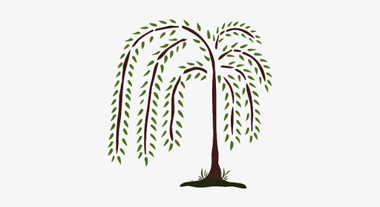
Willow Newsletter Summer 2024
We hope you had a lovely Easter, welcome back to what will be a busy term.
You can contact me directly through email or Class Dojo but please do not send anything urgent as I do not always pick up emails during the school day.
Our topic this term is “Our Colourful World.”
Some of the texts we will use to enhance children’s learning are …
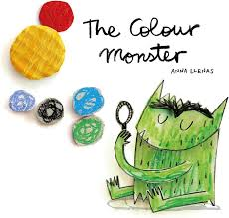

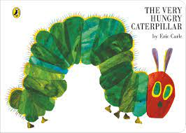
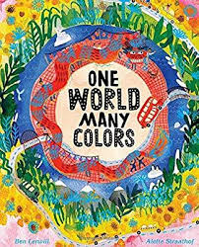

Reminders Children must have a bottle containing water, NOT squash. Sunscreen needs to be applied at home. Children will need a sunhat and also a rain coat in case of showers. Do not send children in with sunglasses. Long hair must be tied back for PE lessons and for Forest School.

Subject | How you can help at home
Literacy  Using some inspirational texts, we will provide motivating reasons to write, including mini beast facts and a letter to a giant. There will be lots of role play opportunities where children can use newly acquired vocabulary. | Encourage children to write for a purpose. Could they write a shopping list or a reminder for you to do something they enjoy? Please encourage your child to form their letters correctly. Visit Letter Join. Username - lj6130. PW on a desktop is home, on a tablet swipe L.
Phonics  Phonics lessons are taught daily using the scheme Supersonic Phonic Friends. Reception will consolidate their knowledge of Basics 3 and practise reading and writing the tricky words as well as spelling words containing the sounds that have been taught. There will be lots of opportunities for children to use their phonic knowledge to write simple captions and sentences.  Year 1 children will move onto Switch it Spell Sounds which covers alternative spellings. The Phonics Screening Check will take place in June. More information will be sent home about this and you will be invited in for an information session. | Please continue to read with your child at home. Going through the sounds in the pink books is beneficial and helps revise the less common sounds. We will change reading books on Monday mornings and you may also wish to use the online Collins E-library. Supporting your child to read their book 5 times, helps build confidence and fluency. In Year 1, children need to read 60 words per minute to comprehend what they have written. This is why reading over and over again is so important.  Year 1 children will continue to receive pseudo words as homework to help prepare them for the  Phonics Screening Check.

Subject | How you can help
Mathematics  This term Reception will be building numbers beyond 10. Children will solve simple addition and subtraction problems using practical equipment. We will do lots of work on becoming familiar with the composition of 10 including learning the number bonds of 10. Children will also start doubling and grouping small amounts.  Year 1 will cover multiplication and division, fractions and place value to 100. In geometry we will explore position and direction and in our unit on measurement will look at money. | Encourage Reception children to recite numbers as far as they can. Provide opportunities for your child to count out up to 20 objects from a larger group. Can they work out what 1 more of 1 less is from a given number? Challenge children to find pairs of numbers to ten and to double small amounts.  Support Year 1 children to count to 100 in 2s, 5s and 10s. Play guess my number to help them identify 1 more or 1 less than any number to 100. Provide children with a selection of coins and help them to identify the different denominations.
Science  We will carry out experiments involving colour to help develop children’s ability to work scientifically. We will then explore the world of plants before learning about min beasts. | Get those green fingers going and help your child to grow plants from seeds. If you don’t have enough garden space cress is an easy win or cherry tomatoes can be grown in a pot. Go on mini beast hunts and see what you can find.
History  We will learn about the local figure Maharaja Duleep Singh and discover what life was like in his lifetime. To enhance our learning, we will visit The Ancient House Museum in Thetford to gain some hands-on experiences of the Victorian period. | Geography  We will be exploring our local area and comparing it with a rural location in India. Children will consider differences in vegetation and weather patterns.  As spring changes into summer we will note the changes that occur in our school setting and ensure we all know how to stay safe in the sun.
Art  Children will explore colour and mix paint to create a colour wheel. Using the artist Kandinsky as inspiration, we will create our own circle paintings. | DT  As part of our topic work we will be making flat bread and tasting some Indian cuisine. We will also learn about what is meant by a balanced diet and prepare some healthy snacks.
PE  This term children will participate in games and athletics during their Friday PE slot. Forest School takes the place of an additional PE session. | Music  Our focus this term will be playing a range of instruments, both individually and together as part of a mini orchestra.
RE  This term in Reception, we will explore Christianity and think about what makes every person unique and also discover how we can care for our wonderful world. Year 1 children will consider these questions. How does celebrating Pentecost remind Christians that God is with them always? Why do Jewish families say so many prayers and blessings? | PSHE  Our unit will explore will personal qualities, strategies to manage feelings, the impact of sleep and relaxation on wellbeing and the importance of hand washing. In the second half of the term we will be thinking about our individual strengths and things we wish to get better at. This forms part of our transition.
Forest School
Sessions will resume on Tuesday afternoons. Children must wear long sleeved tops and trousers/leggings to protect them from brambles and nettles. Long hair should be tied back.

Monday PM | Tuesday PM | Wednesday PM | Thursday PM | Friday PM
RE  PSHE | Topic  Forest School | Science  Music | Art/DT  ICT | PE  Reading

