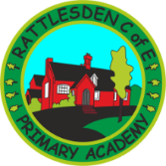 Rattlesden C of E Primary Academy
Believe Embrace Shine Together I can do all things through Christ who strengthens me.’ Phillipians 4:13
Upper Key Stage Two (Year 6) – Religious Education coverage

 | Autumn | Spring | Summer
Teaching and Authority  Life and Death  Encountering | Christianity – Jesus Incarnate  Plus  Islam - Tawid | Hinduism – Braham  Plus  Buddhism – Triple Refuge | Humanism – Happiness  Plus  Christianity – Resurrection.

KS2 Topics in bold should be done first.

