Policy Name:
CHILD PROTECTION and SAFEGUARDING POLICY
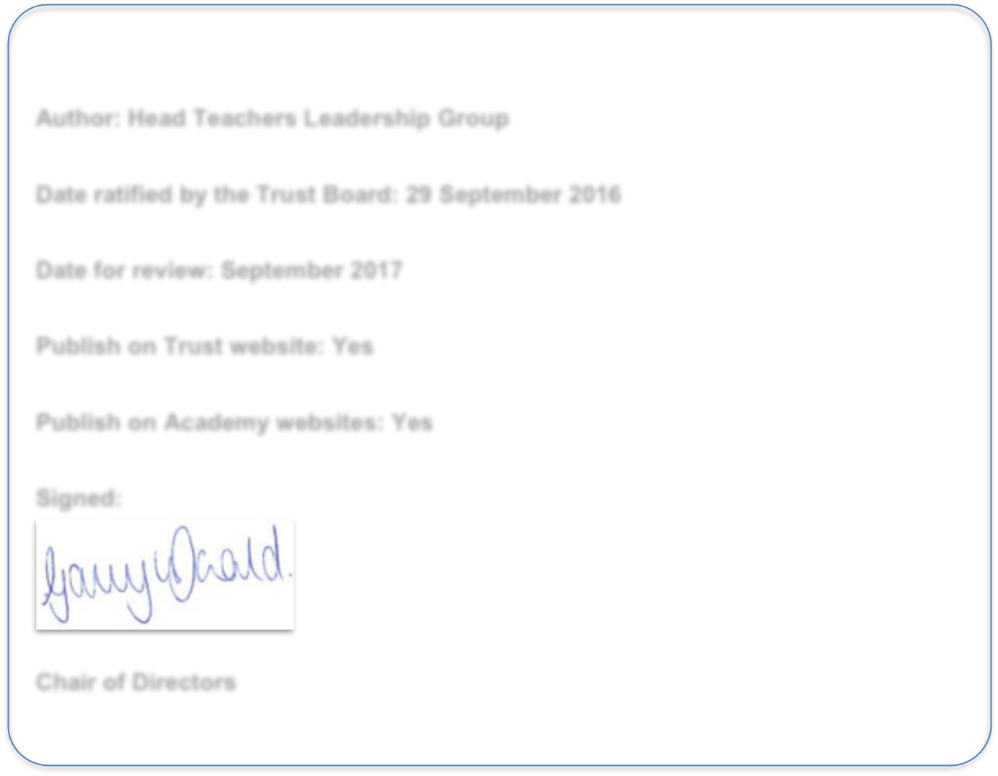

Author: Head Teachers Leadership Group

Date ratified by the Trust Board: August 2019

Date for review: August 2020

Publish on Trust website: Yes

Publish on Academy websites: Yes

Signed:

Chair of Directors

SAFEGUARDING AND CHILD PROTECTION POLICY

Introduction – What this means for everyone of us;

All staff have a responsibility to provide a safe environment in which children can learn.
(Keeping Children safe in Education 2019)

Safeguarding children, promoting their welfare and protecting them from harm is everyone’s responsibility – everyone has a role to play.
(Working Together to Safeguard Children 2018)

Academies within the Thedwastre Education Trust must:

- Ensure children and learners are protected from harm and feel safe

- Ensure children know how to complain and understand the process for doing so

- Are effective in preventing and tackling discrimination and bullying including cyber bullying, racist and homophobic bullying

- Take action following a serious safeguarding incident including online-safety

- Ensure all adults know and understand the indicators that may suggest a child, young person or adult is suffering, or at risk of abuse, neglect or harm and take appropriate action in line with local procedures and statutory guidance

- Ensure that all staff understand that safeguarding is the responsibility of everyone who comes into contact with children and their families

- Respond to the needs of its pupils to prevent the risks of radicalisation and extremist behaviour

- Effectively manage attendance, punctuality, persistent absence and exclusions

- Engage with the local community, including parents, carers, staff and governors

- Always work in the best interest of the child

It is a statutory expectation that Thedwastre Education Trust will have a Safeguarding policy for implementation in all its academies, and that this will be reviewed in discussion with the Trust Board annually.

Aim

The aim of Thedwastre Education Trust’s safeguarding policy is to provide a secure framework for each academy in safeguarding and promoting the welfare of those pupils who attend. We have developed our policy against:

- The Department for Education’s (DfE) statutory guidance for schools and colleges, ‘Keeping children safe in education’ (September 2019), which sets out the responsibilities placed on schools and colleges to safeguard and promote the welfare of children.

- The statutory guidance ‘Working together to safeguard children’ (July 2018), which applies to organisations and professionals who provide services to children

- Information Sharing (July 2018)

- Prevent Duty

- Serious Crime Act 2015 – mandatory reporting of FGM

- Education Inspection Framework (July 2019)

The policy aims to ensure that:

- All our pupils are safe and protected from harm

- Other elements of provision and policies are in place to enable pupils to feel safe and adopt safe practices

- Staff, pupils, governors, visitors, volunteers and parents are aware of the expected behaviours’ and the Trust’s legal responsibilities

Ethos

Safeguarding at every academy within the Thedwastre Education Trust is considered everyone’s responsibility and, as such, each academy aims to create the safest environment within which every pupil has the opportunity to achieve. The Trust recognises the contribution it can make in ensuring that all pupils registered or who use our school, feel that they will be listened to and have appropriate action taken to any concerns they may raise. We will do this by endeavouring to work in partnership with other agencies and seek to establish effective working relationships with parents, carers to develop and provide activities and opportunities throughout our curriculum that will help to equip our children with the skills they need. This will include materials and learning experiences that will encourage our children to develop essential life skills and protective behaviours.

Responsibilities and expectations

Thedwastre Education Trust has a Board whose legal responsibility it is to make sure that each academy has an effective safeguarding policy and procedures in place and to monitor that each academy complies with them. Each Local Governing Body should also ensure that the policy is made available to parents and carers if requested. It is also the responsibility of each Local Governing Body to ensure that all staff and volunteers are properly vetted to make sure they are safe to work with the pupils who attend our academies, and that each academy has procedures for handling allegations of abuse made against members of staff (including the Head Teacher and volunteer helpers). The Local Governing Bodies will ensure that there is a Named Governor for Safeguarding, a Designated Safeguarding Lead (DSL) and at least one Alternate Safeguarding Lead; these people have responsibility for dealing with all safeguarding issues in each academy.

Designated Safeguarding Leads (DSLs)

- The DSL should be a member of the senior leadership team, and should take lead responsibility for safeguarding

- The DSL and/or a deputy/alternate should always be available to staff during school hours in term time. (In the unlikely event that both members of staff are absent at the same time, the academy must have the agreement of the CEO or another DSL to undertake the duties in their absence and staff must be informed of the name and contact details of this person.)

- It is for schools to decide whether to have more than one deputy/alternate DSL. Any deputies/alternates should be trained to the same level as the DSL

- The DSL retains overall responsibility for safeguarding even when the activities associated with the role are delegated to deputies/alternates

- The knowledge and skills of the DSL and his/her alternates should now be updated at regular intervals, but at least annually, to ensure they keep up with developments relevant to the role. This will be provided via e-bulletins, meeting other DSLs, refresher training or by taking time to read about recent safeguarding developments

- DSLs and deputies/alternates must undergo relevant training that is updated every two years

The Designated Safeguarding Lead (DSL) in RattlesdenPrimary Academy is:

Name: Helen Ballam
Tel: 01449 736335

Email: admin@rattlesdenprimaryschool.co.uk

If the DSL is not available, the DSL Alternates are:

Name: Jenny Mills Email: admin@rattlesdenprimaryschool.co.uk

These people can also be contacted with any safeguarding concerns:

The Name Safeguarding Governor at Rattlesden Primary Academy is:

Name: Ian Holman Email: iholmanbarnham@gmail.com

The Chair of Governors (Local Governing Body) is:

Name: Ben Davies

Email: benjdavies72@gmail.com

The Chair of Thedwastre Education Trust is Mr Gary McDonald c/o Thurston CE Primary Academy.

Contact details for Safeguarding Managers who will undertake the role of Local Authority Designated Officer for allegations against all staff and volunteers are: email on LADOCentral@suffolk.gcsx.gov.uk or using the LADO central telephone number 0300 123 2044

Other Useful Contacts:

Suffolk Local Safeguarding Children Board www.suffolkscb.org.uk

Customer First: 0808 800 4005

Police: 999

Child Exploitation and Online Protection Agency www.ceop.org.uk

http://www.thinkuknow.co.uk/

Responsibilities

It is the responsibility of the DSL to ensure that all safeguarding issues raised in school are effectively responded to, recorded and referred to the appropriate agency. The DSL is also responsible for arranging whole-school safeguarding training for all staff and volunteers who work with children and young people in the academy and that this training takes place at least every three years.

Kathy Lambert (DSL at Thurston Primary Academy) has attended the annual ‘Training for Trainers’ programme and is an approved Level 2 safeguarding staff trainer; she is aware that she may receive a monitoring visit from the Professional Advisor or Local Authority delegated staff. She will undertake all basic training in Trust academies.

The DSL at each academy is required to attend, or ensure that a senior member of staff who has the relevant training and access to appropriate supervision, attends where appropriate, all conferences, core groups or meetings where it concerns a child at that academy and to contribute to multi-agency discussions to safeguard and promote the child’s welfare.

The DSL at each academy is also required to complete a Self-Review Assessment Report annually which demonstrates that the safeguarding arrangements in the academy are being met. If the self-assessment highlights any areas for improvement, this will be detailed in the action plan which will be signed off and monitored by the Named Governor for Safeguarding to ensure these improvements are implemented. The self-review assessment is to be shared annually with the Local Authority, who will have an auditing role in ensuring the school/education setting is meeting its safeguarding requirements under sec 175/157 of the Education Act 2002 for both maintained and independent schools.

All Child Protection concerns need to be acted on immediately. If academy staff are concerned that a child may be at risk or is actually suffering abuse, they should inform the Designated Safeguarding Lead immediately, and ensure that all information is recorded on the appropriate form.

All adults, including the DSL, have a duty to refer all known or suspected cases of abuse to Children’s Social Care or the police. Where a disclosure is made to a visiting staff member from a different agency, e.g. Connexions or School Nurse, it is the responsibility of that agency staff to formally report the referral to the Academy’s Designated Safeguarding Lead in the first instance. Where the disclosure is made by a child attending a Pupil Referral Unit (PRU) or alternative provision, the referral should be recorded and referred to the on-site DSL and a formal notification made to the Academy’s DSL where the child is on roll, for information or to agree the appropriate action to be taken. Any records made should be kept securely on the child’s Child Protection file (at the Academy). A referral should not be delayed in order to discuss with the academy’s DSL if it is felt/identified that a child is at immediate risk.

All pupils must be taught about safety and safeguarding. It will be the responsibility of the headteacher in each academy to monitor that teachers do so effectively within the planned curriculum.

What to do if you are concerned

If a child makes an allegation or disclosure of abuse against an adult or other child or young person, it is important that you:

- Do stay calm and listen carefully.

- Do reassure them that they have done the right thing in telling you.

- Do not investigate or ask leading questions.

- Do let them know that you will need to tell someone else.

- Do not promise to keep what they have told you a secret.

  - Do inform your Designated Safeguarding Lead as soon as possible.

  - Do make a written record of the allegation, disclosure or incident using the Trust’s reporting form (appendix 1). Completed forms must be signed, dated and show the position of the person completing the form. This form must be handed to the DSL without delay.

- Do write up and report any conversations and/or discussions and pass these to the DSL, using the Trust’s reporting form.

- Do not include your opinion without stating it is your opinion.

- Do refer without delay.

See appendix A for the flowchart of actions.

Early Help

Where risk factors are present but there is no evidence of a significant risk then the DSL will advise on early help and preventative work that can be done within school to engage the pupil into mainstream activities and social groups. The DSL may well be the person who talks to and has conversations with the pupil family, sharing the school’s concern about the young person’s vulnerability and how the family and school can work together to reduce the risk.

In this situation, we will utilise Suffolk’s Signs of Safety model to consider the needs of the family and in discussion with the parent and the young person (as far as possible).

The DSL may decide to:

- Monitor the situation after taking appropriate action to address the concerns.

- Undertake an Early Help assessment to try to meet the needs of the child and family through a multi-agency approach (CAF, now known as ART).

- Seek advice through the MASH Professionals’ Line if there is any uncertainty.

- Notify Children’s Social Care via a referral to the Multi-Agency Safeguarding Hub (MASH).

If it is felt the child’s needs fall into the Universal + Low Risk to Vulnerable, the DSL will also offer and seek advice about undertaking an early help assessment (CAF, now ART) and consider, if this does not have an impact on the situation making a referral to children's social care.

If the concerns about the pupil are deemed ‘High Risk’, they will be referred to the MASH. This includes concerns about a child/young person who is affected by the behaviour of a parent or other adult in their household.

To assist with the decision making process, Threshold Guidance can be found here:

http://suffolkscb.org.uk/assets/files/2015/2015-01-22-LSCB-Threshold-Matrix-amended-AM-EYC-2.pdf

It is the responsibility of the DSL to arrange a safe place for the return of forms and to acknowledge receipt (if not handed to the DSL in person) to ensure that nothing is missed. If this is not done promptly, the reporter must check that the DSL has received the report.

The DSL will record the decision made following an allegation or receipt of a reporting form. All documentation must be recorded in a named Child Protection file, which must be kept in a locked cabinet.

All documentation can be found on the Suffolk safeguarding website http://suffolkscb.org.uk/

If there is a concern that a member of staff or adult in a position of trust poses a danger to a child or young person, or that they might be abusing a child or young, person, the concerns must be reported to the Headteacher. Where these concerns relate to the Headteacher, this should be reported directly to the Chair of Governors or the Chair of the Board of Directors of the Trust,

using the Trust’s Whistle Blowing policy.

Concerns regarding proprietors of the Trust must be reported to the LADO (LADOCentral@suffolk.gcsx.gov.uk or using the LADO central tel. number 0300 123 2044 ).

Recognising concerns, signs and indicators of abuse

Child Protection and Safeguarding is not just about protecting children from deliberate harm. For our Trust academies, it includes such things as pupil safety, bullying, racist abuse and harassment, educational visits, intimate care, children missing education and internet safety. The witnessing of abuse can have a damaging effect on those who are party to it, as well as the child subjected to the actual abuse, and in itself will have a significant impact on the health and emotional well - being of the child.

Abuse can take place in any family, institution or community setting, by telephone or on the internet. Abuse can often be difficult to recognise as children may behave differently or seem unhappy for many reasons, as they move through the stages of childhood or their family circumstances change. However, it is important to know the indicators of abuse and to be alert to the need to consult further.

The following indicators listed under the categories of abuse are not an exhaustive list.

Abuse

A form of maltreatment of a child. Somebody may abuse or neglect a child by inflicting harm, or by failing to act to prevent harm. Children may be abused in a family or in an institutional or community setting by those known to them or, more rarely, by others. Abuse can take place wholly online, or technology may be used to facilitate offline abuse. Children may be abused by an adult or adults, or another child or children.

Physical abuse

A form of abuse which may involve hitting, shaking, throwing, poisoning, burning or scalding, drowning, suffocating or otherwise causing physical harm to a child. Physical harm may also be caused when a parent or carer fabricates the symptoms of, or deliberately induces, illness in a child.

Physical abuse might be indicated where children have:

- Frequent injuries

- Unexplained or unusual fractures or broken bones

- Unexplained bruises, cuts, burns or bite marks

Emotional abuse

The persistent emotional maltreatment of a child such as to cause severe and persistent adverse effects on the child’s emotional development. It may involve conveying to a child that they are worthless or unloved, inadequate, or valued only insofar as they meets the needs of another person. It may include not giving the child opportunities to express their views, deliberately silencing them or ‘making fun’ of what they say or how they communicate. It may feature age or developmentally inappropriate expectations being imposed on children. These may include interactions that are beyond a child’s developmental capability, as well as

overprotection and limitation of exploration and learning, or preventing the child participating in normal social interaction. It may involve seeing or hearing the ill-treatment of another. It may involve serious bullying (including cyber bullying), causing children frequently to feel frightened or in danger, or the exploitation or corruption of children. Some level of emotional abuse is involved in all types of maltreatment of a child, though it may occur alone.

Signs that indicate emotional abuse include:

- Excessively clingy or attention seeking

- Very low self-esteem or excessive self-criticism

- Lack of appropriate boundaries with strangers; too eager to please

- Eating disorders or self-harm

- Children who are excessively withdrawn, fearful, or anxious about doing something wrong

- Parents or carers who withdraw their attention from their child, giving the child the ‘cold shoulder’

- Parents or carers blaming their problems on their child

- Parents or carers who humiliate their child, for example, by name-calling or making negative comparisons

Child criminal exploitation

As set out in the Serious Violence Strategy, published by the Home Office, where an individual or group takes advantage of an imbalance of power to coerce, control, manipulate or deceive a child or young person under the age of 18 into any criminal activity (a) in exchange for something the victim needs or wants, and/or (b) for the financial or other advantage of the perpetrator or facilitator and/or (c) through violence or the threat of violence. The victim may have been criminally exploited even if the activity appears consensual. Child criminal exploitation does not always involve physical contact; it can also occur through the use of technology

Child Sexual Exploitation

Child sexual exploitation is a form of child sexual abuse. It occurs where an individual or group takes advantage of an imbalance of power to coerce, manipulate or deceive a child or young person under the age of 18 into sexual activity (a) in exchange for something the victim needs or wants, and/or (b) for the financial advantage or increased status of the perpetrator or facilitator. The victim may have been sexually exploited even if the sexual activity appears consensual. Child sexual exploitation does not always involve physical contact; it can also occur through the use of technology.

Sexual abuse might be indicated where children:

- Display knowledge or interest in sexual acts inappropriate to their age

- Use sexual language or have sexual knowledge that you would not expect them to have

- Ask others to behave sexually or play sexual games

- Have physical sexual health problems, including soreness in the genital and anal areas, sexually transmitted infections or underage pregnancy

County Lines

As set out in the Serious Violence Strategy, published by the Home Office, a term used to describe gangs and organised criminal networks involved in exporting illegal drugs into one or more importing areas within the UK, using dedicated mobile phone lines or other form of ‘deal line’. They are likely to exploit children and vulnerable adults to move and store the drugs and money, and they will often use coercion, intimidation, violence (including sexual violence) and weapons.

Neglect

Neglect is the persistent failure to meet a child’s basic physical and/or psychological needs, likely to result in the serious impairment of the child’s health or development.

Neglect may occur during pregnancy as a result of maternal substance abuse. Once a child is born, neglect may involve a parent or carer failing to:

- provide adequate food, clothing and shelter (including exclusion from home or abandonment)

- protect a child from physical and emotional harm or danger

- ensure adequate supervision (including the use of inadequate care-givers); or ensure access to appropriate medical care or treatment

- It may also include neglect of, or unresponsiveness to, a child’s basic emotional needs

Signs of neglect can include children who are:
- living in a home that is indisputably dirty or unsafe
- left hungry or dirty
- often angry, aggressive or self-harm

Extremism

Extremism goes beyond terrorism and includes people who target the vulnerable – including the young – by seeking to sow division between communities on the basis of race, faith or denomination; justify discrimination towards women and girls; persuade others that minorities are inferior; or argue against the primacy of democracy and the rule of law in our society. Extremism is defined in the Counter Extremism Strategy 2015 as the vocal or active opposition to our fundamental values, including the rule of law, individual liberty and the mutual respect and tolerance of different faiths and beliefs. We also regard calls for the death of members of our armed forces as extremist.

Source - Working together to safeguard children 2018

https://www.gov.uk/government/publications/working-together-to-safeguard-children

General signs and symptoms of abuse

For all ages:

- Talks of being left home alone or with strangers.

- Poor bond or relationship with a parent, also known as attachment.

- Acts out excessive violence with other children.

- Lacks social skills and has few if any friends.

Under 5s:

- Doesn’t cry or respond to parent’s presence or absence from an early age.

- Reaches developmental milestones late, such as learning to speak, with no medical reason.

- Significantly underweight but eats well when given food.

Ages 5-11:

- Becomes secretive and reluctant to share information.

- Reluctant to go home after school.

- Unable to bring friends home or reluctant for professionals to visit the family home.

- Poor school attendance and punctuality, or late being picked up.

- Parents show little interest in child’s performance and behaviour at school.

- Parents are dismissive and non-responsive to professional concerns.

- Is reluctant to get changed for sports etc.

- Wets or soils the bed.

Taken from the NSPCC website, for further information: https://www.nspcc.org.uk/preventing-abuse/signs-symptoms-effects/

It is also useful for all staff to be familiar with the document ‘What to do if you’re worried a child is being abused’ Available from: https://www.gov.uk/government/publications/what-to-do-if-youre-worried-a-child-is-being-abused--2

Children with SEN and Disabilities

There are additional safeguarding challenges for children with SEN and disabilities which schools must be aware of:
- Awareness that behaviour, mood and injury may relate to possible abuse and not just their SEN or Disability.
- There is a higher risk of peer group isolation.
- There could be a disproportionate impact of bullying.
- Issues around communication.

Consideration should be given to extra pastoral support and guidance for these children.

Managing allegations

We are aware of the possibility of allegations being made against members of staff or volunteers that are working or may come into contact with children and young people whilst in our academies. Allegations can be made by children and young people or other concerned adults and are made for a variety of reasons.

If an allegation is made against an adult in a position of trust, whether they be members of staff or volunteers, this should be brought to the immediate attention of the DSL who will advise the Headteacher (if not the same person). In the case of the allegation being made against the Headteacher, this will be brought to the immediate attention of the Chair of Governors and the Chair of Directors of the Thedwastre Education Trust. The Headteacher/Chair of Governors must also discuss with the Local Authority Designated Officer (LADO) the nature of the allegations in order for the appropriate action to be taken. In Suffolk this role is undertaken by the Area Safeguarding Manager. This will constitute an initial evaluation meeting or strategy discussion involving the LADO. Dependant on the allegation being made, Head teachers will need to:

- Refer to the LADO immediately and follow up in writing within 48 hours. In Suffolk schools should refer in the first instance to the Area Education Manager.

- Consider safeguarding arrangements of the child or young person to ensure they are away from the alleged abuser.

- Contact the parents or carers of the child/young person if advised to do so by the LADO.

- Consider the rights of the staff member for a fair and equal process of investigation.

- Ensure that the appropriate disciplinary procedures are followed including whether suspending a member of staff from work until the outcome of any investigation is deemed necessary.

- Act on any decision made in any strategy meeting or evaluation meeting.

- Advise the Independent Safeguarding Authority where a member of staff has been disciplined or dismissed as a result of the allegations being founded

Training

- All members of staff and volunteers will have access to whole-school Child Protection training at least every two years.
- In addition, it is the responsibility of the governing body to ensure the completion and record of a risk assessment must happen for all volunteers.
- It is the responsibility of the governing body to ensure that if staff are employed from alternative providers written confirmation must be recorded on vetting checks.
- We will also, as part of our induction, issue information in relation to our Child Protection policy, require the member of staff to read Keeping Children Safe in Education 2019 (Part One) and any other policy related to safeguarding, and promote our commitment to ensuring the safety of children/young people in our care. These policies must include:
  - The Child Protection Policy
  - The Behaviour Policy
  - The staff behaviour policy/Code of Conduct
  - Schools response to children who go missing in education
  - The role of the designated safeguarding lead
- All staff working directly with children must read Part One of KCSiE (2019) and Annex A along with Part One. This includes:
  - Children and the court system (as witnesses)
  - Children missing in education
  - Children with family members in prison
  - Child sexual exploitation
  - County Lines
  - Domestic abuse
  - Homelessness
  - So called ‘honour based’ violence including female genital mutilation and forced marriage (new 2019)
  - Preventing radicalisation
  - Peer on Peer abuse
  - Sexual violence and sexual harassment
  - Upskirting is now a criminal offence (new 2019)
- Annex H in the new guidance explains the substantive differences from September 2018.

- All staff will be issued with regular updates through bulletins and staff updates. Notifications will be available on the staff notice board (safeguarding area).

- The Designated Safeguarding Leads and Alternates will undertake further safeguarding training in addition to the whole school training. This will be undertaken at least every two years which updates their awareness and understanding of the impact of the wide agenda of safeguarding issues. This will support both the DSL/Alternate to be able to better undertake their role and support the Trust in ensuring that our safeguarding arrangements are robust and achieve better outcomes for the pupils in our academies. Designated Safeguarding Leads and Alternate Safeguarding Leads are required to attend higher level training every three years called ‘Working Together to Safeguard Children Level 3 (Multi-agency).

- Our Governing body will have access to Safeguarding training and our Named Governor for Safeguarding will also undertake additional training at least every two years to support their employers’ role in Handling Allegations against adults who work with children and young people, including our staff and volunteers. Governors must be trained separately from staff.

- All staff will be issued with Part 1 of the DfE document ‘Keeping Children Safe in Education’ and Annex A and are required to sign that they have received a copy. All staff and volunteers will be required to follow the Trust’s Code of Conduct (2018) and will be required to sign that they have received a copy of the document. This will be on display in each academy for staff and volunteers.

- Our safeguarding arrangements are reported on a termly basis to our Governing body and our Safeguarding policy is reviewed annually, in order to keep it updated in line with local and national guidance/legislation.

- We will include a summary of our Safeguarding Policy to parents in our academy prospectus/website and will post copies of our policy throughout each academy. We are also able to arrange for our policy to be made available to parents whose first language is not English on request.

Current safeguarding issues

Children and the Court System
https://assets.publishing.service.gov.uk/government/uploads/system/uploads/attachment_data/file/708114/ywp-5-11-eng.pdf
Children with family members in prison
https://www.nicco.org.uk/
An estimated 200,000 children every year have a parent in prison in England and Wales and 10,000 visits are made by children to our public prisons every week.NICCO lists comprehensive information from voluntary and statutory agencies across England and further afield. The three Directories enable practitioners to search for Services, Resources or Research to inform their practice with children and families of offenders.

Drugs (County Lines)

https://www.gov.uk/government/publications/drugs-advice-for-schools

Homelessness

Being homeless or being at risk of becoming homeless presents a real risk to a child’s welfare. The designated safeguarding lead (and any deputies) should be aware of contact details and referral routes in to the Local Housing Authority so they can raise/progress concerns at the earliest opportunity. Indicators that a family may be at risk of homelessness include household debt, rent arrears, domestic abuse and anti-social behaviour, as well as the family being asked to leave a property. Whilst referrals and or discussion with the Local Housing Authority should be progressed as appropriate, this does not, and should not, replace a referral into children’s social care where a child has been harmed or is at risk of harm.

The Homelessness Reduction Act 2017 places a new legal duty on English councils so that everyone who is homeless or at risk of homelessness will have access to meaningful help including an assessment of their needs and circumstances, the development of a personalised housing plan, and work to help them retain their accommodation or find a new place to live. The following factsheets usefully summarise the new duties: Homeless Reduction Act Factsheets. The new duties shift focus to early intervention and encourage those at risk to seek support as soon as possible, before they are facing a homelessness crisis.

The following safeguarding concerns actual or suspected should be referred immediately to Children’s’ Social Care. The concerns featured below are linked to guidance and local procedures which, where available, can be found on the Suffolk Safeguarding Children Board website at: www.suffolkscb.org.uk.

Some members of our communities hold beliefs that may be common within particular cultures but which are against the law of England. Thedwastre Education Trust does not condone practices that are illegal and which are harmful to children
Examples of particular practices are:

Radicalisation and extremism

All academies within Thedwastre Education Trust have a duty to ensure that all staff and governors are trained in ‘Prevent’.

From 1 July 2015 all schools are subject to a duty under section 26 of the Counter -Terrorism and Security Act 2015 (“the CTSA 2015”), in the exercise of their functions, to have “due regard13 to the need to prevent people from being drawn into terrorism”. This duty is known as the ‘Prevent Duty’.

At each academy, the governor for Safeguarding must ensure that the Designated Safeguarding Lead has undertaken or is committed to the Prevent awareness training and is able to provide advice and support to other members of staff and governors about protecting children from the risk of radicalisation. Should there be a suspicion of Radicalisation or Extremism, staff will follow the agreed Child Protection/Safeguarding system and report to the DSL in the first instance.

Thedwastre Education Trust ensures that children are safe from terrorist and extremist material when accessing the internet in each academy by ensuring that suitable filtering is in place. All academies are required to teach pupils about online safety more generally.

Channel

Channel is a programme which focuses on providing support at an early stage to people who are identified as being vulnerable to being drawn into terrorism. It provides a mechanism for schools to make referrals if they are concerned that an individual might be vulnerable to radicalisation. School staff should understand when it is appropriate to make a referral to the Channel programme. This training will be led by the DSL following Prevent awareness training.

Visiting speakers

It is the responsibility of the headteacher of each academy to ensure that any visiting speakers are suitable and appropriately supervised at all times. A risk assessment should be in place for any one off volunteers.

Prior to a visit, the purpose and content of the session must be agreed, and, ideally, submitted in advance.

Preventing Extremism

Role of the Single Point of Contact (SPOC)

The SPOC/DSL is responsible for:

- Ensuring that staff of the school are aware that you are the SPOC in relation to protecting students/pupils from radicalisation and involvement in terrorism;

- Maintaining and applying a good understanding of the relevant guidance in relation to preventing pupils from becoming involved in terrorism, and protecting them from radicalisation by those who support terrorism or forms of extremism which lead to terrorism.

  - Raising awareness about the role and responsibilities of the academy in relation to protecting pupils from radicalisation and involvement in terrorism.

- Monitoring the effect in practice of the school’s RE curriculum and the assembly policy to ensure that these are used to promote community cohesion and tolerance of different faiths and beliefs.

- Raising awareness within the school about the safeguarding processes relating to protecting students/pupils from radicalisation and involvement in terrorism.

- Acting as the first point of contact within the academy for case discussions relating pupils who may be at risk of radicalisation or involved in terrorism.

- Collating relevant information in relation to referrals of vulnerable pupils into the Channel process.

- Attending Channel meetings as necessary and carrying out any actions as agreed.

- Reporting progress on actions to the Channel Co-ordinator and sharing any relevant additional information in a timely manner.

Forced marriage

Thedwastre Education Trust does not support the idea of forcing someone to marry without their consent and will follow SCB procedures to refer any child and young person immediately to Children’s Social Care.

Honour based violence

Honour Based Violence ‘is a crime or incident, which has or may have been committed to protect or defend the honour of the family and/or community’. It is important to be alert to signs of distress and indications such as self-harm, absence from school and truancy, infections resulting from female genital mutilation, isolation from peers, being monitored by family, not participating in school activities, unreasonable restrictions at home or forced marriage. Where it is suspected that a child/young person is at risk form Honour Based Violence, the DSL will report those concerns to the appropriate agency in order to prevent this form of abuse taking place.

Trafficked children

Child trafficking involves moving children across or within national or international borders for the purposes of exploitation. Exploitation includes children being used for sex work, domestic work, restaurant/ sweatshop, drug dealing, shoplifting and benefit fraud. Where an academy is made aware of either the suspicion of being trafficked/exploited, or actually being trafficked/exploited, the DSL will report the concerns to the appropriate agency.

Child Sexual Exploitation (CSE)

Child sexual exploitation is a form of sexual abuse where children are sexually exploited for money, power or status. It can involve violent, humiliating and degrading sexual assaults. In some cases, young people are persuaded or forced into exchanging sexual activity for money, drugs, gifts, affection or status. Consent cannot be given, even where a child may believe they are voluntarily engaging in sexual activity with the person who is exploiting them. Child sexual exploitation does not always involve physical contact and can happen online. A significant number of children who are victims of sexual exploitation go missing from home, care and education at some point.

Some of the following signs may be indicators of sexual exploitation:

- Children who appear with unexplained gifts or new possessions.

- Children who associate with other young people involved in exploitation.

- Children who have older boyfriends or girlfriends.

- Children who suffer from sexually transmitted infections or become pregnant.

- Children who suffer from changes in emotional well-being.
  - Children who misuse drugs and alcohol.

  - Children who go missing for periods of time or regularly come home late, and

- Children who regularly miss school or education or do not take part in education.

(Keeping Children Safe in Education 2019)

Female Genital Mutilation (FGM)

FGM is against the law in England, yet for some communities, it is considered a religious act and cultural requirement. It is illegal for someone to arrange for a child to go abroad with the intention of having her circumcised. If any of the above areas of concern is brought to the attention of an academy within the Trust, the DSL will report those concerns to the Police and Social Care in order to prevent this form of abuse taking place; it is a mandatory duty to report FGM personally to the police for any girl under 18 years old.

FGM comprises all procedures involving partial or total removal of the external female genitalia or other injury to the female genital organs. It is illegal in the UK and a form of child abuse with long-lasting harmful consequences. Section 5B of the Female Genital Mutilation Act 2003 (as inserted by section 74 of the Serious Crime Act 2015) places a statutory duty upon teachers along with regulated health and social care professionals in England and Wales, to report to the police where they discover (either through disclosure by the victim or visual evidence) that FGM appears to have been carried out on a girl under 18. Those failing to report such cases will face disciplinary sanctions.

It will be rare for teachers to see visual evidence, and they should not be examining pupils, but the same definition of what is meant by “to discover that an act of FGM appears to have been carried out” is used for all professionals to whom this mandatory reporting duty applies. Information on when and how to make a report can be found at https://www.gov.uk/government/publications/mandatory-reporting-of-female-genital-mutilation-procedural-information.

Teachers must personally report to the police cases where they discover that an act of FGM appears to have been carried out and should discuss any such case with the designated safeguarding lead and involve children’s social care as appropriate. The duty does not apply in relation to at risk or suspected cases (i.e. where the teacher does not discover that an act of FGM appears to have been carried out, either through disclosure by the victim or visual evidence) or in cases where the woman is 18 or over. In these cases, teachers should follow local safeguarding procedures.

Children Missing from Education (CME)

Too many children are either missing out on full-time education or not getting the part-time education they are entitled to. (Ofsted November 2013)

Children are best protected by regularly attending school where they will be safe from harm and where there are professionals to monitor their well-being. At Thedwastre Education Trust’s academies, we will encourage the full attendance of all our children. Where we have concerns that a child is missing education and/ or because of suspected abuse, we will report to Childrens’ Social Care and the Education Attendance/Welfare Service to effectively manage the risks and to prevent abuse from taking place.

It is the responsibility for all staff to be vigilant and report any concerns about children who may go missing. In each academy, it is the responsibility of the headteacher to ensure that checks are made for all leavers. The headteacher must check that a child who has left the academy arrives at the destination school. Where there is a concern about the whereabouts of a child, the headteacher must complete the appropriate CME form and return to the local authority without delay. For children who leave an academy to be home schooled, a CME form and an EHE form must be completed and sent to the local authority. All Trust academies must follow the advice in Keeping Children Safe in Education 2019, Annex A.

Withdrawal from school to electively home educate

When a school receives written notification from a parent of their intention to home educate their child, it is the responsibility of the school to:

- acknowledge the parents’ letter in writing and to delete the child’s name from the school register. The local authority (LA) requires the school to do this within 3 working days of receiving the parents’ letter

- inform the LA immediately of the removal of the child’s name from the register (Section 12 (3) of 'The Education (Pupil Registration) (England) Regulations 2006')

Schools should inform the LA of the removal of a child’s name from the register by completing roll removal form ‘NCME20’ and posting it to:

CHILDREN MISSING EDUCATION OFFICER for Suffolk

Children & Young Peoples Services
Suffolk County Council

Endeavour House

Ipswich.

IP1 2BX

Form ‘NCME20’ can also be emailed to the secure GCSx email address of:

cme@suffolk.gcsx.gov.uk to comply with the data protection policy.

Schools also need to complete EHE FORM 1, available from the Elective Home Education Team and returned to:

EHE Business Support Officer

CYPS, Suffolk County Council
Lime Block Floor 1

Endeavour House

8 Russell Road
Ipswich

Suffolk

IP1 2BX

or email: ehe@suffolk.gcsx.gov.uk

(Information taken from Suffolk LA website)

Abuse linked to faith and beliefs

Some faiths believe that spirits and demons can possess people (including children). What should never be considered is the use of any physical or psychological violence to get rid of the possessing spirit. This is abusive and will result in a criminal conviction of those using this form of abuse even if the intention is to help the child.

Sexually active under eighteen years old

It is acknowledged by those working with young people, that some young people under the age of 18 will have an interest in sex and sexual relationships. The Protocol for Sexually Active Young People under 18 years old has been designed to assist those working with children and young people to identify where these relationships may be abusive, and the children and young people may need the provision or protection of additional services. Thedwastre Education Trust will ensure our policy for managing this issue links to the available protocol.

Safeguarding disabled children

Disabled children have exactly the same human rights to be safe from abuse and neglect, to be protected from harm and achieve the Every Child Matters outcomes as non-disabled children. Disabled children do however require additional action. This is because they experience greater risks as a result of negative attitudes and ‘created vulnerability’. This may lead to disabled children having unequal access to services and resources, and because they may have additional needs relating to physical, sensory, cognitive and/ or communication impairment (Safeguarding Children, DCSF, July 2009).

Thedwastre Education Trust will ensure that any disabled children in its academies are listened to and responded to appropriately where there are concerns regarding abuse. In order to do this we will ensure that our staff and volunteers receive the relevant training to raise awareness and have access to specialist staff in the event they have concerns regarding the abuse of a disabled child.

Domestic abuse

The Government defines domestic abuse as” Any incident of threatening behaviour, violence or abuse (psychological, physical, sexual, financial or emotional) between adults who are or have been intimate partners or family members regardless of gender or sexuality”

Children may suffer both directly and indirectly if they live in households where there is domestic violence. Domestic abuse is likely to have a damaging effect on the health, development and welfare of children, and it will often be appropriate for such children to be regarded as Children in Need under the Children Act 1989.

Where there is evidence of domestic violence, Thedwastre Education Trust will require DSLs to report concerns to the appropriate agencies, including children’s social care and the police, in order to prevent the likelihood of any further abuse taking place.

Private fostering

Private fostering is an arrangement made between the parent and the private foster carer, who then becomes responsible for caring for the child in such a way as to safeguard and promote his/her welfare.

A privately fostered child means a child under the age of 16 (18 if a disabled child) who is cared for more than 28 days and where the care is intended to continue and provided with accommodation by someone other than:

- A parent.

- A person who is not a parent but has parental responsibility.

- A close relative.
- A Local Authority.

It is a statutory duty to inform the local authority where we are made aware of a child or young person who may be subject to private fostering arrangements.

Child exploitation

Children and young people can be exploited by their associations and through gang activity. They may suffer exploitation through their use of modern technology such as the internet, mobile phones and social networking sites. In order to minimise the risks to our children and young people, our academies will ensure that we have in place appropriate measures such as security filtering, and an Acceptable Use policy linked to our Online-Safety policy. We will ensure that staff are aware of how not to compromise their position of trust in school or outside school and are aware of the dangers associated with the internet and other mobile technology.

Online-safety

Thedwastre Education Trust’s Online-Safety policy clearly states that mobile phone or electronic communications with a pupil is not acceptable other than for approved academy business e.g. coursework, mentoring. Where it is suspected that a child is at risk from internet abuse or cyber bullying we will report our concerns to the appropriate agency.

Peer on peer abuse

Staff must be aware that safeguarding issues can arise between pupils. Examples include:

- Bullying, including cyber bullying

- Gender based violence/sexual assaults

- Sexting

Pupils are taught to talk to an adult if they are worried, and taught to recognise bullying, in its many forms. Staff must be vigilant to changes in behaviour and monitor carefully, both in class and at playtimes. Any concerns must be passed to the DSL/ASL.

Should a child make an allegation, the child will be supported initially by staff. Additional professional support will be sought if necessary. Support for the bully/abuser will also be sought, to minimise risk in future. This may be through the Early Help team. Any unlawful behaviour will be reported to the Police. Where appropriate, the headteacher will take statements from all concerned and follow procedures in the Behaviour/Discipline/Bullying policy, ensuring that parents are informed. The DSL will be informed and appropriate reporting procedures followed.

Safeguarding children and young people linked to gang activity

Thedwastre Education Trust will endeavour to protect all children and young people from exposure to gang activity and exploitation by having robust attendance and behaviour policies and to act on relevant information or allegations. We will take all reports seriously and will share this information appropriately with other agencies to safeguard our pupils from harm.

The above list is not exhaustive and as new policy guidance and legislation develops within the remit of Safeguarding we will review and update our policy as appropriate and in line with the Local Safeguarding Children Board and Local Authority to ensure all academies within the Trust are safe places to learn and work.

Safer Recruitment and Selection

It is a requirement for all agencies to ensure that all staff recruited to work with children and young people are properly selected and checked (see Safer Recruitment Policy)

Thedwastre Education Trust will ensure that we have a member on every recruitment panel who has received the appropriate recruitment and selection training, that all of our staff are appropriately qualified and have the relevant employment history and checks to ensure they are safe to work with children in compliance with the Key Safeguarding Employment Standards.

Thedwastre Education Trust requires a 'section 128 direction' check to be carried out on anyone involved in the management of an academy (either as an employee or a governor/trustee). Checks for section 128 directions can be carried out via the Teacher Services system, and are also covered by Disclosure and Barring Service (DBS) barred list checks.

All academies are required to follow the guidance in ‘Keeping Children Safe in Education’, Part 3.
For further information and advice contact MASH.

Multi-Agency Safeguarding Hub (MASH)
The Suffolk MASH (Multi Agency Safeguarding Hub) has been developed from lessons highlighted by reviews of serious safeguarding incidents across the country. A recurrent theme of these reviews is the importance of having effective information sharing and close working arrangements between relevant agencies, with the need to ensure referrals and referrers get the right response first time.
Building on the long established close partnership between local agencies, the MASH receives and processes all safeguarding referrals in respect of children without an allocated social worker and all vulnerable adults at risk of harm and abuse. Customer First is, and will continue to be, the first point of contact for all referrers to report safeguarding concerns for both children and adults. All non-safeguarding referrals for adults will be directed to the cluster teams.
MASH staff work together in an integrated model to identify the most appropriate response to an individual`s identified needs. The emphasis is on effective sharing of information to ensure early identification of harm, and to trigger the correct interventions, and route referrals to the right services.
The MASH is staffed by a range of professionals from Health, Police, Education, Social Care, Probation, Youth Offending, Mental Health services and Housing, with the majority of staff being based in Landmark House, Ipswich. The MASH also has a strong partnership working with wider partners including schools, the Ambulance Service and voluntary and community organisations.
The MASH has a leadership team of managers from all of the partner agencies. The MASH Strategic Board is responsible for providing robust governance of the MASH and ensures statutory and local policy objectives are met.
Please feel free to view the MASH film
Please also see the MASH Service Structure

If you think someone is at risk
If you are worried that a child, young person or adult is at risk of abuse, harm or neglect, please call Customer First on 0808 800 4005.

MASH Professional Consultation Line
However experienced professionals are, there may be times where they are not sure what action they should take, or they just need support and guidance to ensure they make the most informed decision.

The MASH Consultation Line is for a professional, such as a teacher, care worker or GP, to discuss the most appropriate and effective way of providing or obtaining help and support and recognising if there is a requirement for a referral to be submitted for a child or adult they feel is at risk of abuse.
Where the child or vulnerable adult may need help and protection they will be given advice and guidance about making a referral, including how to involve family members where appropriate. Where a child and family have an allocated Social Worker, the professional will need to contact the named Social Worker or Lead professional to discuss any concerns.

This Policy should be read in conjunction with the Online-Safety Policy/Acceptable Use Policy

Useful Contacts:
Multi-agency Safeguarding Hub (MASH) Professional Helpline: 0345 606 1499

Customer First (Professional Referral Line) for use in emergencies only: 0345 606 6167
Customer First: 0808 800 4005
Police (emergency only): 999
Suffolk Police main switchboard: 01473 613500
Suffolk Police Cybercrime Unit: 101
Suffolk Local Safeguarding Children Board www.suffolkscb.org.uk
Suffolk County Council: www.suffolk.gov.uk/community-and-safety/staying-safe-online/e-safer-suffolk/

Appendix A
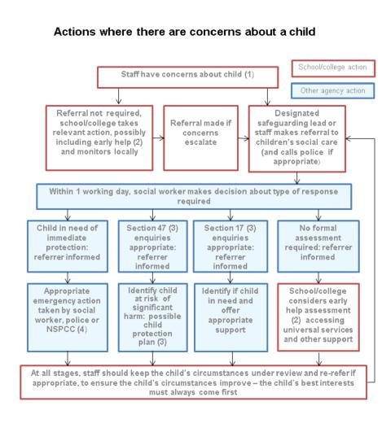

Appendix B
Record of concern about a child/young person’s safety and welfare
Part 1 (for use by any staff – must be handwritten and legible)
Pupil’s name: |  | Date of birth: | Class/Form:
Date & time of incident: |  | Date & time  (of writing):
Name (print): Job title:
Signature:
Record the following factually: Nature of concern, e.g. disclosure, change in behaviour, demeanour, appearance, injury, witnesses etc. (please include as much detail in this section as possible. Remember – the quality of your information will inform the level of intervention initiated. Attach additional sheets if necessary.
What is the pupil’s perspective?
Professional opinion, where relevant (how and why might this have happened?)
Any other relevant information. Previous concerns etc. (distinguish between fact and opinion)
Note actions, including names of anyone to whom your information was passed and when
Check to make sure your report is clear to someone else reading it.
Please pass this form to your DSL without delay
Record of concern about a child/young person’s safety and welfare
Part 2 (for use by DSL)
Information received by DSL: | Date: |  | Time completed: |  |  |  | From whom:
Any advice sought, if applicable | Date: |  | Time completed: |  |  |  | From: name/organisation:
 | Advice received:
Action taken with reasons recorded  (e.g. MARF completed, monitoring advice given to appropriate staff, CAF etc) | Date: |  | Time completed: |  |  |  | By whom:
Outcome | Date: |  | Time completed: |  |  |  | By whom:
Parent/carer informed? | Y | Who spoken to: |  | Date: |  |  |  | Time: |  |  | By whom:
 | N | Detail reason:
Is any additional detail held, if so where?

Prior safeguarding history | No. of previous records of concern:
 | Has the child been subject of CAF/Early Help assessment?
 | Currently on CP Plan (CPP) / Child in Need Plan (CiN)
 | Previously on CP Plan (CPP) / Child in Need Plan (CiN)
 | Is child known to other agencies? |  |  |  |  | Y / N
Name of DSL: |  |  |  |  | Signature:

Appendix C

BODYMAP
(This must be completed at time of observation)

Name of Pupil: |  |  | Date of Birth:
Name of Staff: |  |  | Job title:
Date and time of observation:

Name of pupil: |  |  | Date and time of observation:
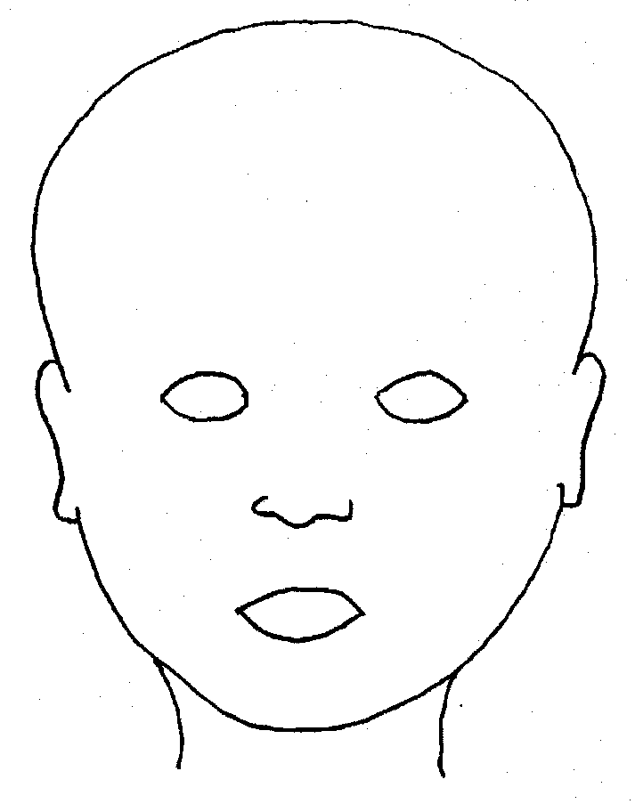
FRONT |  | BACK
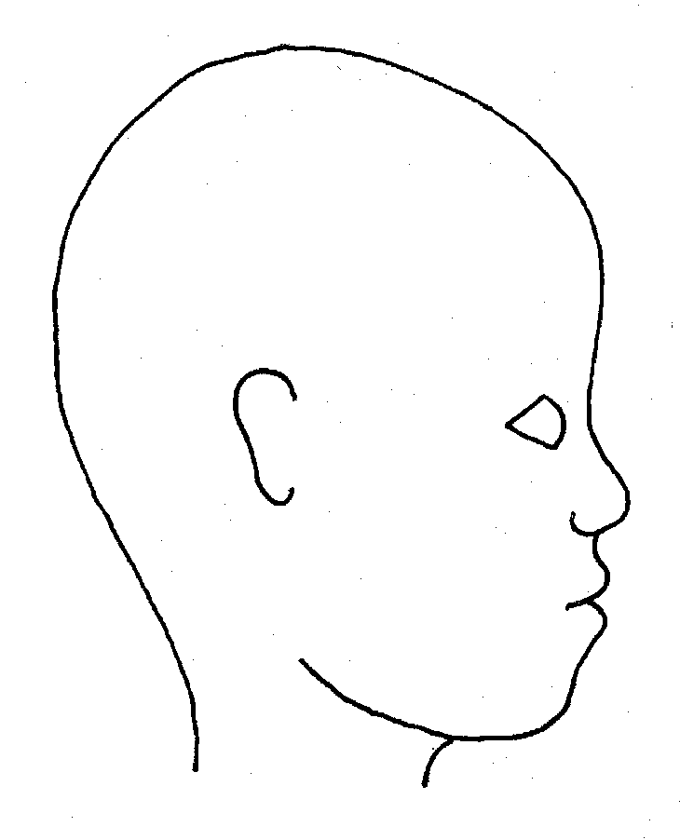 |  | 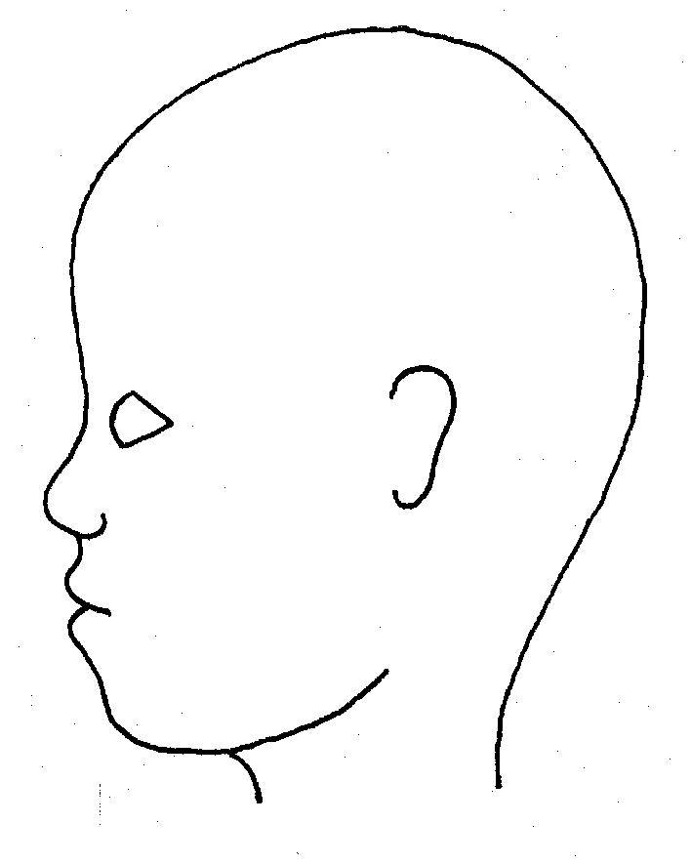
RIGHT |  | LEFT

Name of pupil: |  |  |  |  |  |  | Date and time of observation:
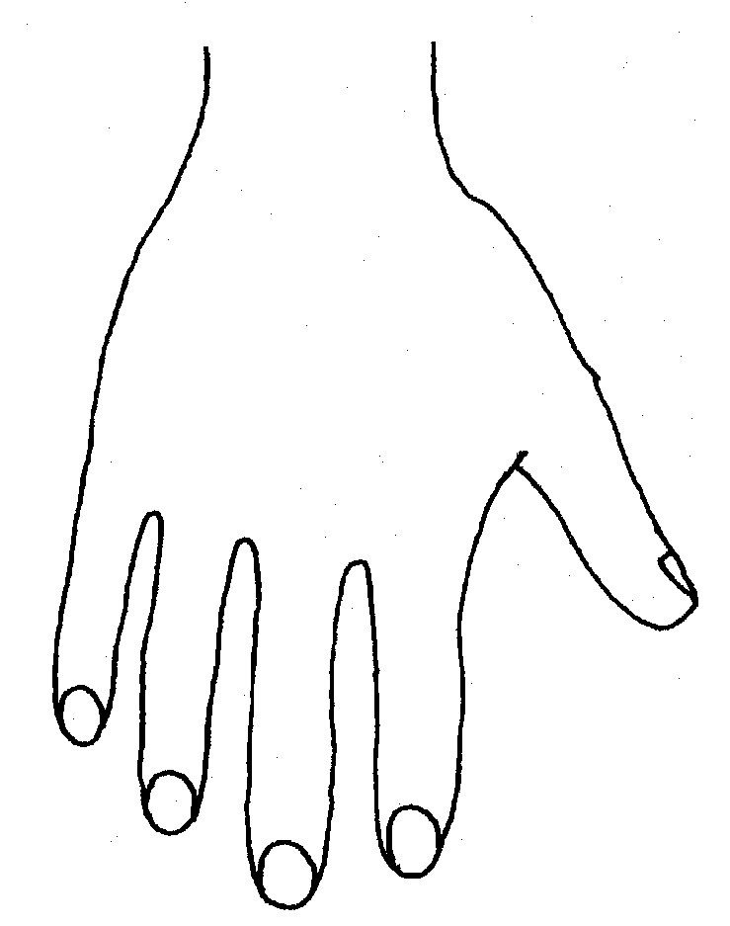 |  |  |  |  |  | 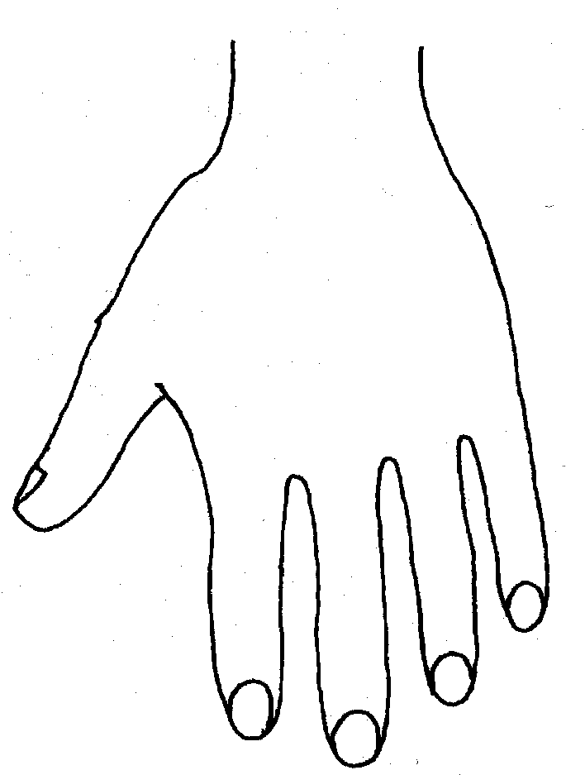
R |  |  |  |  |  | L
BACK
Name of Pupil: |  |  |  |  |  |  | Date and time of observation:
R | TOP |  |  | L | R |  |  | BOTTOM |  |  |  | L
R |  |  |  |  | L
INNER
R |  |  |  |  | L
OUTER
Printed Name, Signature and Job title of staff:

