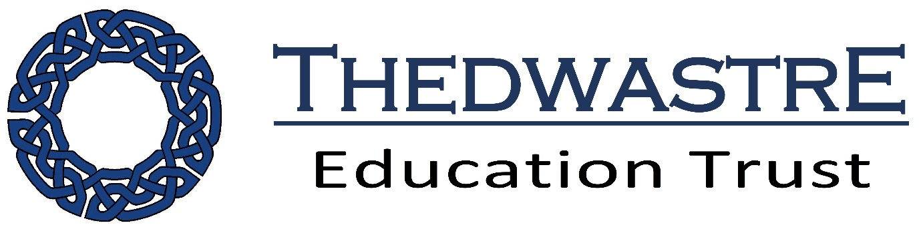

Privacy Notice: School Workforce
May 2018
Rattlesden CofE Primary Academy
Headteacher: Helen Ballam
Contact details:01449 736335

Privacy Notice (How we use school workforce information)

This privacy notice explains how we collect, process and manage information for the school workforce. That includes employed members of staff, volunteers, including trustees and governor, trainee teachers, apprentices and work experience/workplace placements.

The categories of school workforce information that we collect, process, hold and share include:
- personal information (such as name, employee or teacher number, national insurance number)
- special categories of data including characteristics information such as gender, age, ethnic group
- contract information (such as start dates, hours worked, post, roles and salary information)
- work absence information (such as number of absences and reasons)
- qualifications (and, where relevant, subjects taught)
- medical information
- other personal information
- references
- payroll

Why we collect and use this information
We share information to comply with statutory, regulatory and contractual obligations. These may include, but are not limited to:

      - improving the management of workforce data across the sector
- enabling development of a comprehensive picture of the workforce and how it is deployed
- pay salaries and pension contributions
- informing the development of recruitment and retention policies
- allowing better financial modelling and planning
- enabling ethnicity and disability monitoring
- supporting the work of the School Teachers’ Review Body
- comply with guidance such as ‘Working Together’ and safeguarding obligations
- facilitating good governance
- internal reviews and quality monitoring
- CPD and staffing issues.

If we are required to comply with other legal obligations not listed above, we will share data only when it is lawful to do so.

The lawful basis on which we process this information
We must make sure that information we collect and use about our workforce is in line with the GDPR and Data Protection Act. This means that we must have a lawful reason to collect the data, and that if we share that with another organisation or individual we must have a legal basis to do so.

The lawful basis for schools to collect and process information comes from a variety of sources, such as Article 6 and Article 9 of the GDPR and the Safeguarding of Vulnerable Groups Act 2006. We also have obligations to organisations such as HMRC and the Department of Work and Pensions.

Collecting this information
Whilst the majority of information you provide to us is mandatory, some of it is provided to us on a voluntary basis. In order to comply with data protection legislation, we will inform you whether you are required to provide certain school workforce information to us or if you have a choice in this.

Storing this information
The retention period for school workforce data is set out in our Data Retention Policy (see academy/trust websites)

Who we share this information with
We routinely share this information with:

- our local authority
- the Department for Education (DfE)
- safeguarding and protection for children and vulnerable adults
- payroll services
- legal advisers
- insurance providers
- HMRC
- Teacher Pension Scheme and the Local Government Pension Scheme (and other pension providers)
- health professionals
- Thedwastre Trust
- SBM
- SchoolComms
- Capita

Why we share school workforce information
We do not share information about workforce members with anyone without consent unless the law and our policies allow us to do so.

Local Authority
We are required to share information about our workforce members with our local authority (LA) under section 5 of the Education (Supply of Information about the School Workforce) (England) Regulations 2007 and amendments.

Department for Education (DfE)
We share personal data with the Department for Education (DfE) on a statutory basis. This data sharing underpins workforce policy monitoring, evaluation, and links to school funding / expenditure and the assessment educational attainment.

We are required to share information about our pupils with the (DfE) under section 5 of the Education (Supply of Information about the School Workforce) (England) Regulations 2007 and amendments.

Data collection requirements
The DfE collects and processes personal data relating to those employed by schools (including Multi Academy Trusts) and local authorities that work in state funded schools (including all maintained schools, all academies and free schools and all special schools including Pupil Referral Units and Alternative Provision). All state funded schools are required to make a census submission because it is a statutory return under sections 113 and 114 of the Education Act 2005

To find out more about the data collection requirements placed on us by the Department for Education including the data that we share with them, go to https://www.gov.uk/education/data-collection-and-censuses-for-schools.

The department may share information about school employees with third parties who promote the education or well-being of children or the effective deployment of school staff in England by:

- conducting research or analysis
- producing statistics
- providing information, advice or guidance.

The department has robust processes in place to ensure that the confidentiality of personal data is maintained and there are stringent controls in place regarding access to it and its use. Decisions on whether DfE releases personal data to third parties are subject to a strict approval process and based on a detailed assessment of:

- who is requesting the data
- the purpose for which it is required
- the level and sensitivity of data requested; and
- the arrangements in place to securely store and handle the data.

To be granted access to school workforce information, organisations must comply with its strict terms and conditions covering the confidentiality and handling of the data, security arrangements and retention and use of the data.

For more information about the department’s data sharing process, please visit:
https://www.gov.uk/data-protection-how-we-collect-and-share-research-data

To contact the department: https://www.gov.uk/contact-dfe

Requesting access to your personal data
Under data protection legislation, you have the right to request access to information about you that we hold. To make a request for your personal information, contact the school office/Justine Berkeley at SBM services (DPO)

You also have the right to:

- object to processing of personal data that is likely to cause, or is causing, damage or distress
- prevent processing for the purpose of direct marketing
- object to decisions being taken by automated means
- in certain circumstances, have inaccurate personal data rectified, blocked, erased or destroyed; and
- claim compensation for damages caused by a breach of the Data Protection regulations

If you have a concern about the way we are collecting or using your personal data, we ask that you raise your concern with us in the first instance. Alternatively, you can contact the Information Commissioner’s Office at https://ico.org.uk/concerns/

Further information
If you would like to discuss anything in this privacy notice, please contact: The school office/Justine Berkeley at SBM services (DPO)

More information about Data Protection and our Policies

How we manage the data and our responsibilities to look after and share data is explained in our Data Protection policy and connected policies which are also available on our website.

