Pupil premium strategy statement

This statement details our school’s use of pupil premium (and recovery premium for the 2021 to 2022 academic year) funding to help improve the attainment of our disadvantaged pupils.

It outlines our pupil premium strategy, how we intend to spend the funding in this academic year and the effect that last year’s spending of pupil premium had within our school.

School overview
Detail | Data
School name | Rattlesden Primary
Number of pupils in school | 125
Proportion (%) of pupil premium eligible pupils | 14%
Academic year/years that our current pupil premium strategy plan covers | 3 years
Date this statement was published | 13.09.21
Date on which it will be reviewed | 10.01.22
Statement authorised by | Phil MacKay
Pupil premium lead | Helen Ballam
Governor / Trustee lead | Gill Marchant
Funding overview
Detail | Amount
Pupil premium funding allocation this academic year | £28, 245
Recovery premium funding allocation this academic year | £145x17 pupil = £2465
Pupil premium funding carried forward from previous years (enter £0 if not applicable) | £0
Total budget for this academic year  If your school is an academy in a trust that pools this funding, state the amount available to your school this academic year | £30, 710

Part A: Pupil premium strategy plan

Statement of intent
Our ultimate objective for our disadvantaged children is that all pupils are able to reach their full academic potential, across the curriculum. All children, despite the challenges they face, have the right to an education that improves their chances to succeed in life, not only academically, but socially and emotionally too. We wish all of our children to thrive at Rattlesden and build their confidence and resilience to take forward with them to secondary school.
Our current pupil premium plan provides bespoke and targeted support for our children. Each child is seen as an individual, and is discussed with the headteacher and all staff, to build specific support for that child, based on barriers faced, support given, and termly reviews. As in previous years, it has been written based on EEF guidance.
Our key principles are:
- Bespoke support for individual children.
- Good mental health and well-being is our first priority
- Children feel safe, happy and ready to learn
- Attainment is in-line or above national levels, and progress is maintained
- Extra-curricular opportunities are available and encouraged
- High expectations of behaviour and attendance
- Families are supported and equipped to support their child, via strong and close relationships
- Being a nurturing, approachable school with an ’open door’ policy to support pupils and families
- Continued support, when moving to another school, or transitioning to upper school.

Challenges

This details the key challenges to achievement that we have identified among our disadvantaged pupils.
Challenge No. | Detail of challenge
1 | Low prior attainment – in some cases exacerbated through moving schools
2 | Specific additional needs included those being supported as SEN
3 | Weaknesses in learning behaviours e.g. lack of independence, resilience or confidence
4 | Social, emotional and behavioural problems affecting wellbeing and progress
5 | Improved attendance.

Intended outcomes
This explains the outcomes we are aiming for by the end of our current strategy plan, and how we will measure whether they have been achieved.
 | Intended outcome | Success criteria
1 | Good progress | - Triangulation of earning walks, observations and book scrutinies evidence good progress.  - Attainment scores are in line or above national average.
2 | Additional needs are supported effectively | - Observations , learning walks, regular summative and formative assessments, pupil perception evidence that all pupils needs are being met.
3 | Improved learning behaviours | - Displays in POD, children using the language of growth mindset. pupil perception of impact  - Pupils are well behaved at all time and with all adults.  - The number of incidences of poor behaviour recorded on CPOMS are monitored and show reduction over time.  - Pupil and parent perceptions/interviews state that children believe behaviour is good, and feel safe and happy consequently.
4 | Good progress in Social, emotional and behavioural issues | - Records from nurture groups, pupil perception. Behaviour incident reports scrutinised and reported to GB.  - Maintain Silver membership to SSP and provide PP chn with supported provision  - The number of PP children attending clubs is maintained compared to last year, and proportionate to non- PP
5 | Improved attendance | - Attendance for our pupil premium children remains at or above national levels  - Breakfast club and After School Club attendance should remain steady or improve.

Activity in this academic year
This details how we intend to spend our pupil premium (and recovery premium funding) this academic year to address the challenges listed above.

Teaching (for example, CPD, recruitment and retention)
Budgeted cost: £6169 (Unqualified teacher £18,169 – £12,000 as TA previously difference)

Activity | Evidence that supports this approach | Challenge number(s) addressed
Small group support for pupils that are ‘just below’ in Years 3,4 and 5 | Targeted support via linked structured small group intervention from previous teacher, who knows the pupils well. | 1, 2, 3
Training of unqualified teacher that enables us to split R/1 class and teach the Year 1’s separately and all year 1’s separately in Phonics. 2 Year course assessed by SCITT. | Training and succession planning with existing staff within our school is an effective tool for ensuring high quality teaching. | 1, 2, 3
Our teachers are experienced and graded as being either good, or better. They welcome ongoing CPD, are members of subject associations and embrace updated pedagogy and debate. They champion mental health and well-being throughout the school. | High staff retention  Low staff absence  CPD is effective and has impact (Jane Considine, Paul Dix)  Teachers are supported to keep improving, and therefore improve pupil outcomes. | 1, 2, 3

- Targeted academic support (for example, tutoring, one-to-one support structured interventions)
Budgeted cost: Additional teacher 1 day per week: £3, 700 (20 days) Carla x 20 days
Visits: £1000
MDS/Play leader to target specific PP pupils with challenging behaviour: 5x lunchtimes £2000
Residential: £300
Clubs subsidy: £1000

Total: 8, 000
Activity | Evidence that supports this approach | Challenge number(s) addressed
Booster groups in year 6 SATs prep (Spring/summer 2022) and Teacher and TA support.  Tailored small group intervention TA (CF)  Pupil Premium mentor | Best practice according to EEF is 1 to 1 and small group tuition regularly.  A pupil premium mentor will identify and implement individual interventions to move children to make than expected progress. | 1, 2,
1 to 1 (CF)/small group to support the needs of identified pupils with additional needs engaging with the curriculum. | Research evidence of effectiveness of quality 1 to 1 as a tool to move pupils learning forward  Bespoke support to meet the needs of identified learners with specific additional needs for learning and behaviour | - 2, 3, 4

- Wider strategies (for example, related to attendance, behaviour, wellbeing)
- Breakfast club (based on 1 pupil attending every school day @£2.50 a day): £500
- After school wrap around care until 5.30 (based on 1 pupil attending every school day @ £7.50): £2, 850
- Learning mentor – Flexible ‘On-call’ support and designated pupil times. Quiet club. Staff development: £9,860
Total: 13, 710
Activity | Evidence that supports this approach | Challenge number(s) addressed
Nurture groups  Trips and extra-curricular clubs subsidised | Children have barriers to learning if their emotional wellbeing affects their behaviour and attitude to school. The nurture work in school helps children to feel secure and cared for.  Sporting opportunities for children that show aptitude and interest. Before and after school provision. Wrap around care. | 3, 4
Improved attendance. | Breakfast club and after school provision have proven benefits to those who attend, modelling good behaviour, the chance to eat a healthy breakfast and improving punctuality.  Out of school hours provision is provided for PP children with no charge so parents receive wrap around care. | 3, 4, 5
Additional hours continue to train Learning Mentor | Many of our children have low self-esteem and belief in their own capabilities. Growth Mindset has shown itself to be a powerful tool in turning around negative fixed mindset.  Our Learning mentor will work with Lego and Sand therapy and work with small nurture groups/individual support. She will cascade training from Dr Beth Mosely through the school staff when it is re-established. | 3, 4

Total budgeted cost: £27, 879

Service pupil premium funding
Measure | Details
How did you spend your service pupil premium allocation last academic year? | - Additional pastural support for SPP pupils.  - Additional academic interventions.  - Breakfast and after school club available led by school staff.  - Additional staffing to enable bubbles to operate during lockdown and remote learning offer to improve.
What was the impact of that spending on service pupil premium eligible pupils? | Pupils eligible for SPP had access to effective support for social, emotional, mental health and behavioural needs.  SP pupils had additional support and interventions for both academic and mental wellbeing in response to covid- 19 lockdowns.

Allocated amount 21-22:
1 pupil: £310

Further information
The Pupil Premium is funding provided to schools which is additional to main school funding. It is allocated according to the number of pupils on-roll who are eligible for free school meals (FSM), a smaller amount allocated according to the number of children of service families (this is accounted for in a separate Service Pupil Premium Statement), and an allocation for each pupil who has been ‘Looked After’ (in care) for 6 months or more. In 2012, funding was extended to include pupils who have been eligible for free school meals within the past 6 years.
We organise teaching and learning at Rattlesden CofE Academy in order to meet the needs of all children in the best way.
We ensure that appropriate provision is made for children who belong to vulnerable groups and that socially disadvantaged children have their needs adequately assessed and met.
We recognise that not all children who receive Pupil Premium will be socially disadvantaged and we also recognise that not all children who are disadvantaged are in receipt of Pupil Premium. We offer support to any child that the school has identified as disadvantaged or at risk of underachieving.

Part B: Review of outcomes in the previous academic year

Pupil premium strategy outcomes
This details the impact that our pupil premium activity had on pupils in the 2020 to 2021 academic year.
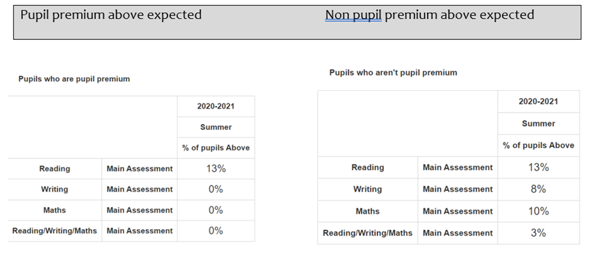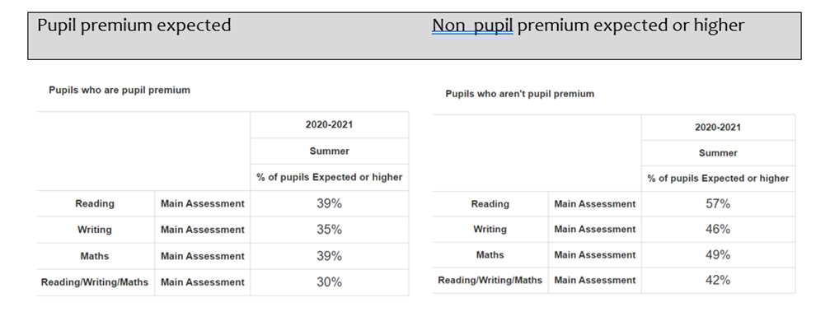

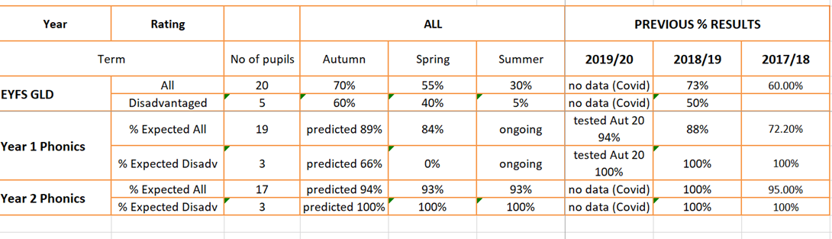

Pupils outcomes were considerably lower in reading. We believe this is because although parents may hear their children read, comprehension including inference and deduction was not taught. The quality and amount of reading material was also limited to online or school swaps during lockdown.
The number of pupils achieving GLD was lower than previous years. Children had experienced a disrupted, or very limited pre-school experience and in many cases were not school ready, especially with speech and language development. Greater parent involvement would improve outcomes
Numbers of pupils entering from out of catchment have risen, including additional PP children.
Attendance was at above national until COVID-19 outbreak
PP pupil behaviour was good and learning attitudes were good positive and resilient throughout the pandemic.
Children made expected progress from their starting points until point of school closure
The Learning Mentor continued to support vulnerable PP pupils during lockdown/home learning. Communication and continuity provided was essential to their engagement with online learning, and supporting families.
Booster lessons will be for individual intervention due to the small number of pupils in the current Year 6.
PP pupils in Year 6 are below expected. Gaps will be identified, and teacher will aim to close those and bring disadvantaged pupils up to expected standard.
Training will hopefully be reinstated after the pandemic(Human Toolbox) and connection with Dr Beth Mosely
Lego club was also a good additional skill-based club, and the children were able to relax and discuss issues freely.

Clubs could have more structure and be more selective and less open-ended to the pupils that attended. Keep numbers low.

Externally provided programmes
Please include the names of any non-DfE programmes that you purchased in the previous academic year. This will help the Department for Education identify which ones are popular in England
Programme | Provider
The Write Stuff | Jane Considine
White Rose

Further information (optional)
Use this space to provide any further information about your pupil premium strategy. For example, about your strategy planning, or other activity that you are implementing to support disadvantaged pupils, that is not dependent on pupil premium or recovery premium funding.

