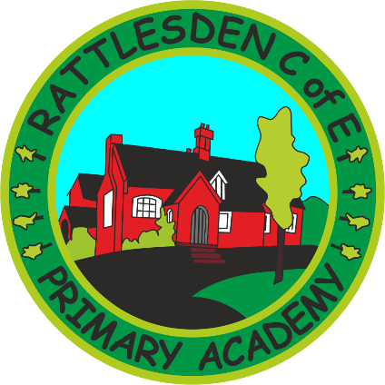
SMSC Policy

 | Name |  | Signature |  | Date
Prepared by: | G Marchant |  |  |  | March 2018
Checked and Reviewed by: | Governing Body
Approved by: | Governing Body
Document Title: | Policy – Spiritual, Social, Moral and Cultural Development
Version Number: | 1 | Date of Next Review: |  | March 2020

Our Vision –
Through a positive caring environment, we provide the opportunity for every child to reach their full potential. We embrace Christian values and ensure all children are ready for their next steps. We ensure that British Values are embedded into all we do (see British Values Policy).
Aims and Objectives
At Rattlesden C of E Primary Academy we strive to create a learning environment which promote respect, diversity and self-awareness and equips all of our pupils with the knowledge, skills, attitudes and values they will need to succeed in their future lives.
The curriculum provides a wide range of artistic, sporting and cultural opportunities that encourage pupils to work together and use imagination in their learning. Activities are planned that require pupils to reflect and empathize with others as well as giving them the confidence to provide their opinions and develop their own view points. We use the Values for Life materials in our worship sessions and closely link SMSC with our schemes of work as appropriate.
Spiritual Development
Definition: Spiritual development focuses on an individual’s own personal beliefs and values and their resulting behaviour. Through spiritual development, children are able to understand their own feelings and emotions and this enables them to reflect and to learn.
Curriculum opportunities enable pupils to:
• Be curious and to express feelings of delight and wonder, (scientific investigations, new life, the global landscape)
• Empathise and consider the viewpoints of others, (debates, drama activities, discussing feelings and empathising with characters in familiar stories)
• Consider how a belief can change people’s lifestyles, (R.E, investigating communities and faiths, historical case studies)
• Discuss what they think they have achieved and what they need to do to be successful in the future, (self-assessment, target setting activities)
Moral Development
Definition: Moral development means exploring, understanding and recognising shared values and considering the issues of right and wrong.
The classroom environment and curriculum promote moral development through:
• Codes of conduct and class rules, agreed with children and displayed in the classroom
• Clear and consistent rewards and sanctions that children understand and believe to be fair.
• Class and school collective worship that discuss moral values and cite expectations.
• Activities that enable pupils to give opinions and show they are valued.
• Discussions on choices made by pupils and others and the resulting outcomes, character studies, studies of historical figures.
• The values of ‘Justice’ and ‘Forgiveness’ are explicitly taught and modelled throughout the school.

Social Development
Definition: Social development involves learners working effectively together and participating successfully in the school community as a whole. During a pupil’s social development they gain interpersonal skills that allow them to form successful relationships and to become a positive team member.
Social skills are developed through:
• Modelling positive social behaviour by all staff
• After school clubs
• Sporting activities
• Buddy and team games at play times and lunch times
• Turn taking and team building activities
• Pair and small group work within the classroom
• Working with others across the local community
The values of ‘Friendship’, ‘Generosity’, ‘Trust’, ‘Courage’ and ‘Perseverance’ are explicitly taught and modelled throughout the school
Cultural Development
Definition: Cultural development enables learner’s to develop an understanding of their own culture and of other cultures locally, nationally and internationally. It also means learning to feel comfortable in a variety of cultures and valuing cultural diversity.
Children are introduced to a regional and global perspective in life through:
• Keeping up to date with National and International news through the children’s newspaper ‘First News’.
• Stories from different cultures
• First hand experiences through local visits, theatre, art and artists
• Visitors from the local and international community
• Being part of National and International fund raising events
• Studies of a different lifestyle including different food, dress, festivals and places of worship.
• Links with local and international communities.
Monitoring and review
SMSC is monitored termly by the head teacher and RE coordinator and reviewed annually with all staff.

