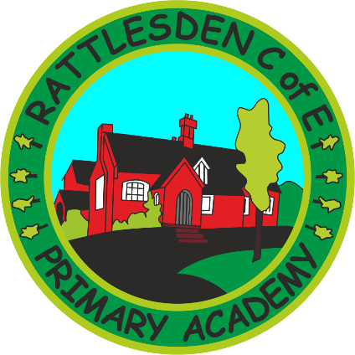
RE Policy

 | Name |  | Signature |  | Date
Prepared by: | Jenny Bishop |  |  |  | June 2021
Checked and Reviewed by: | Governing Body
Approved by: | Governing Body
Document Title: | Policy – RE
Version Number: | 1 | Date of Next Review: |  | Autumn 2024

STATUTORY REQUIREMENTS

The Education Act 1996 states that Religious Education (RE) must reflect the fact that religious traditions are mainly Christian, whilst taking account of the teachings and practices of the other principal religions represented in the country.

RE is required to be included, alongside the National Curriculum, in the basic curriculum which all maintained schools must provide for their registered pupils. This includes those in Early Years and post 16 Education.

RE is not a National Curriculum subject, but rather is determined locally. Because we are a Voluntary Controlled school, we use the Suffolk Agreed Syllabus of Religious Education 2012 as the basis of our planning and delivery of RE. This is delivered through the resource ‘the Emmanuel Project’, developed by the diocese of St Edmundsbury and Ipswich. KS1 follow a two year cycle and Years 3, 4 and 5 follow a three year cycle.

AIMS

RE provokes challenging questions about the ultimate meaning and purpose of life, beliefs about God, the self and the nature of reality, issues of right and wrong and what it means to be human. It challenges pupils to reflect on, consider, analyse, interpret and evaluate issues of truth, belief, faith and ethics and to communicate their responses. The aim of RE in Rattlesden Primary Academy is to:

- Promote the spiritual, moral, cultural and social development of each pupil in a sensitive and careful manner.
- Enrich pupils’ experiences and to enable them to be tolerant of other people’s viewpoints, beliefs and customs.
- Create an atmosphere appropriate for contemplation and reflection.
- Develop the value of the individual, the values within the school, the local community and the world at large.
- Give pupils an opportunity to investigate their own religious viewpoints in relation to others by offering them new experiences.
- Provide a programme for progressive and differentiated learning which caters for pupils’ needs and is sensitive to individuals and groups
- Develop a sense of mystery and fascination about the world.

A variety of teaching methods are used in the teaching of RE, including role play/drama, stories and music. Visitors to school are also welcomed giving the children the opportunity to listen to and ask questions about another person’s experiences of living/celebrating through different faiths.

Assessment

The two attainment targets, Learning about Religion (AT 1) and Learning from Religion (AT 2), with their associated statements set out the broad objectives in terms of knowledge, understanding and skills for the RE curriculum. RE is at its most effective when these two attainment targets are closely related in the learning experience.

Pupils are assessed regularly on both attainment targets and parents informed annually on their child’s achievements in RE.

Equal Opportunities

We believe that it is important for all children to have access to opportunities for spiritual development and awareness and for understanding of the great religious traditions. The teaching of RE is approached sympathetically to all religious beliefs and teachers remain mindful of the PREVENT and British Values Policy throughout the process of planning and teaching.

Special Educational Needs

RE is taught at a level appropriate to the age, ability and experience of the pupils and is therefore accessible to all

Parental Rights

Parents have the right to withdraw their child from RE. Where parents are wishing to exercise this right, we suggest that they meet with the Head teacher first to discuss their concerns. If the matter cannot be resolved, parents need to apply, in writing, to withdraw their child from RE lessons. Arrangements will then be made for the child(ren) to be supervised or engaged in another activity during this time.

Role of the Co-ordinator

There is a named co-ordinator: responsible for co-ordinating the teaching of RE throughout the school. Their role is to:
- Provide support, advice and resources to members of staff
- Monitor the teaching or RE and outcomes for all children,
- Revise policies and support staff with planning of RE where necessary.

Collective Worship

Although RE and Collective Worship naturally compliment and enrich each other, they are managed separately within the school.

