Autumn 2021

A Guide to Maths
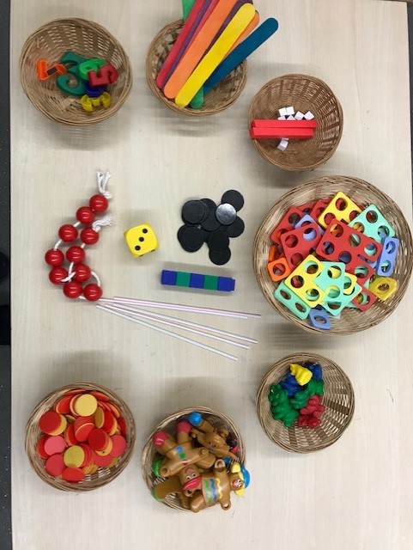
Mastery in Reception

Rattlesden C of E Primary Academy

At Rattlesden Primary Academy we want pupils to gain a deep understanding of maths. By teaching for mastery in maths we are allowing them to acquire a secure and long-term understanding of maths which allows them to make continual progress to move onto more complex topics.

We believe that everyone can do maths and that maths is a subject in which everyone can and should be able to perform confidently and competently.

We break down maths objectives into the smallest steps, so that every pupil is secure before moving on. We focus upon teaching for fluency, reasoning and problem solving.

There are two Early Learning Goals for Maths. This is what most children are expected to achieve by the end of Reception.

Number: Have a deep understanding of number to 10, including the composition of each number.
Subitise (recognise quantities without counting) up to 5.
Automatically recall (without reference to rhymes, counting or other aids) number bonds up to 5 (including subtraction facts) and some number bonds to 10, including double facts.

Numerical Patterns: Verbally count beyond 20, recognising the pattern of the counting system.
Compare quantities up to 10 in different contexts, recognising when one quantity is greater than, less than or the same as the other quantity.
Explore and represent patterns within numbers up to 10, including evens and odds, double facts and how quantities can be distributed equally.

How do we teach for Mastery in Reception?
Fluency
In Reception, we aim to teach so that children have a deep understanding of number.
Representing Numbers
We want to develop children’s number sense so that they understand the number rather than just recognising the numeral. Children need to understand that numbers can be represented in many ways not just as a written numeral. We use many different objects and pictures to show that numbers can be represented in lots of different ways.
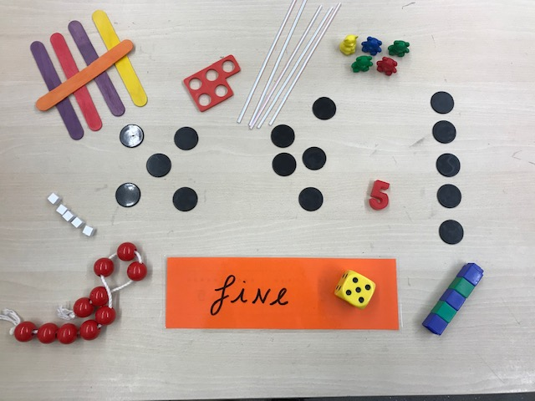
Some ways to represent 5

Children sometimes need lots of practise to recognise numbers in different forms. We play lots of matching games and encourage children to recognise and make different amounts using a range of media both indoors and out.
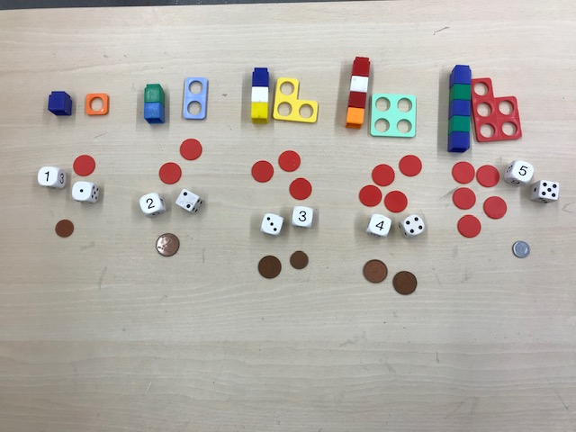

Counting
When counting children need to recognise that:
- We need to say one number for each object counted (touch counting)
- The final number we say is how many altogether. Some children continue to count after they have reached the final object as they don’t yet connect the numbers they are saying to the objects in front of them. Likewise, if children count a group of objects and you ask them how many there were, they should be able to tell you the last number they said. If they begin recounting they have not made the connection.
- That we can count objects in any order and the total stays the same.

Recognising amounts
Another skill, subitising, that is very important is recognising small amounts without the need to count them. Initially this should be done by using concrete objects in a regular arrangement e.g. dice spots, an array or 5 cubes in a tower. As children progress allowing them to see dots in different arrangements helps them to mentally ‘see’ how many objects there are without needing to count. This is a very important skill when children begin to add and subtract. Using a dice is a good way to practise this as is moving objects into different arrangements.

Understanding that the total stays the same even when the objects move

When children first start to use numbers, they often do not understand that if we move objects into another arrangement the total stays the same. We practise this with many different types of objects but a useful tool is a tens frame to be able to move counters around.

By using counters of two different colours, is also a good way to begin adding and subtracting and learning number bonds.

By becoming fluent in maths facts, it allows our brain to concentrate on the higher level skills.

Reasoning
Reasoning in maths helps children explain their thinking therefore making it easier for them to understand what is happening to the maths they are doing. It helps them to think about how to solve a problem, explain how they solved it and to think about what they could do differently.
In Reception some examples of reasoning are:
True and false statements e.g. adding one to a number always makes it smaller
Spotting incorrect maths e.g. 1, 2, 3, 4, 6, 5, 7, 8, 9, 10
Explaining how we know something or how we worked it out

Problem solving
Problem solving in maths allows children to use their maths skills in lots of contexts and in situations that are new to them. It allows them to seek solutions, spot patterns and think about the best way to do things rather than blindly following maths procedures.

In Reception problem solving might include:
Spotting, following and creating patterns
Estimating amounts of objects
Predicting how many things they can do something in 1 minute
Sharing objects between different groups – particularly when the number of groups change and the number of objects stays the same
Finding different way to split number e.g. 5 cold be 5+0 or 4+1 or 3+2 etc

Maths is practical, we provide children with lots of ways to explore

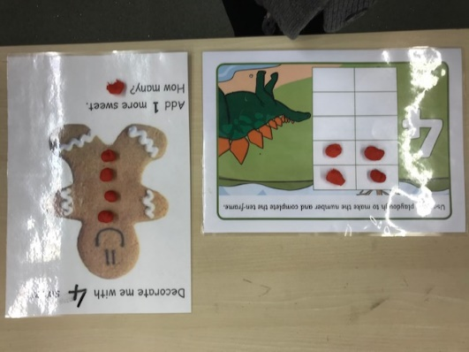
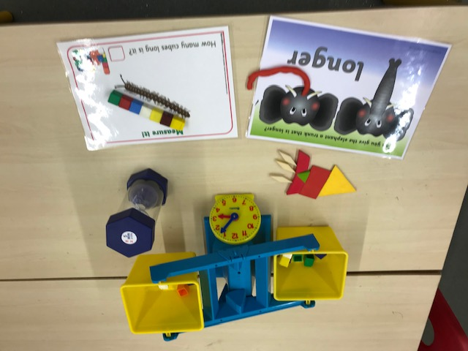
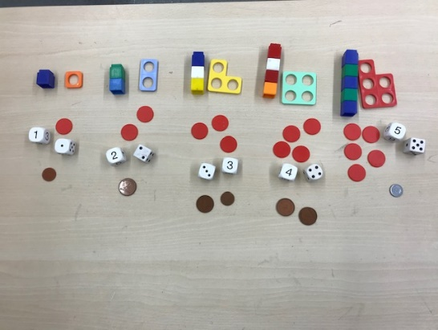

How you can help at home
Make the most of any opportunity to count – steps up the stairs, money into a box, cups, apples in a bag etc
Ask children to say how many without counting (5 or less)
Play games with a dice and encourage children to say how many without counting
Ask children to set the table with enough cutlery and plates for everyone
Spot, point out and talk about numbers in the environment – phones, microwaves, clocks, car registrations, door numbers etc
Ask children to think of their own representations for numbers e.g. 1 of them, 2 hands, 3 wheels on a tricycle, 4 wheels on a car, 5 toes, 6 sides on a cube, 7 dwarves, 8 legs on a spider etc
Deliberately make mistakes. Children need to know that it is ok to make mistakes and that everyone does it. They also absolutely love pointing them out! Get mixed up when counting or place two numbers out of sequence when ordering
Watch Numberblocks on Cbeebies, this programme is written by maths specialists to model maths concepts and represents number brilliantly. Numberjacks is also good for solving problems
Hide numbers around the house for children to find
Play hopscotch and skittles or allow children to devise their own game with a point scoring system
Read books with number concepts e.g. The Very Hungry Caterpillar, One is a snail, ten is a crab, What’s the time Mr Wolf?
Draw attention to more and less
Play guessing games – I’m thinking of a number and it in between 1 and 3…etc
Cook with your child and encourage them to weigh and measure
Ask questions such as “How many More?” “How many altogether?” “How many would I have if….?”

