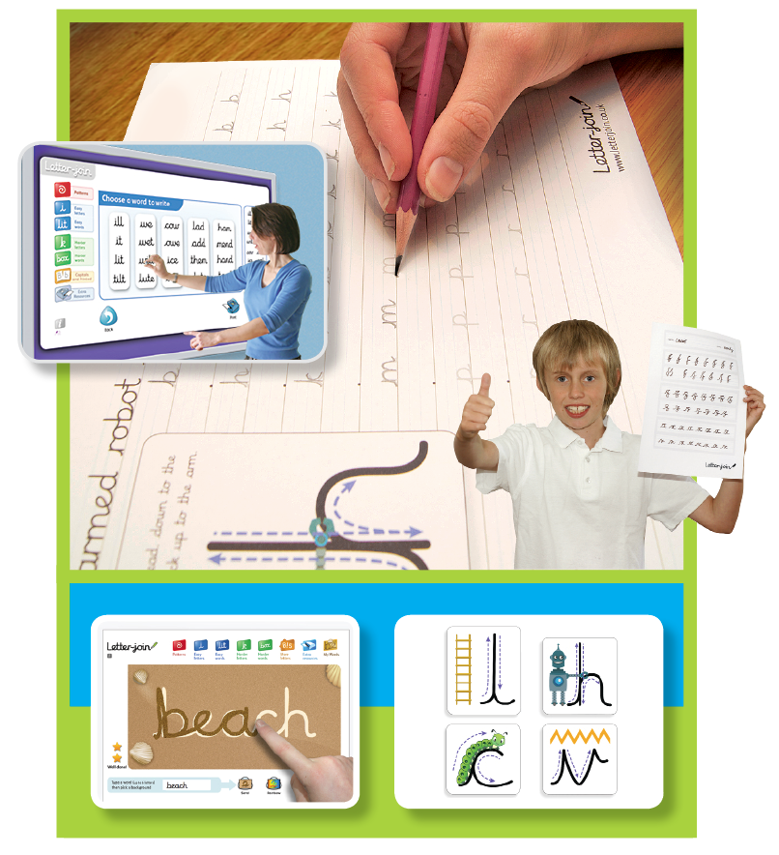

**Handwrting Policy**

|  |  |  |  |  |  |
| --- | --- | --- | --- | --- | --- |
|  | Name | | Signature | | Date |
| Prepared by: | Mrs McIntosh | |  | | Autumn 2017 |
| Checked and Reviewed by: | Governing Body | |  | |  |
| Approved by: | Governing Body | |  | |  |
| Document Title: | Policy – Handwriting | | | | |
| Version Number: | 1 | Date of Next Review: | | Autumn 2019 | |

Handwriting Policy

Here at Rattlesden Academy we are very proud of our pupil’s handwriting and take particular care in our cursive/joined-up handwriting style. We use Letter-join as the basis of our handwriting policy that covers all the requirements of the 2014 National Curriculum.

Handwriting is a basic skill that influences the quality of work throughout the curriculum. At the end of Key Stage 2 all pupils should have the ability to produce fluent, legible and, eventually, speedy joined-up handwriting, and to understand the different forms of handwriting used for different purposes.

We aim to make handwriting an automatic process that does not interfere with creative and mental thinking.

As a catalyst to speedy handwriting we encourage parents and carers to use the Letter-join resources at home and can arrange for free access to the Home Edition of Letter-join.

.



Handwriting frequency

Handwriting is a cross-curriculum task and will be taken into consideration during all lessons. Formal teaching of handwriting is to be carried out regularly and systematically to ensure Key Stage targets are met.

FOUNDATION:

For our youngest pupils we aim for two to three weekly sessions totalling 30 to 45 minutes that will include the following;

* Movements to enhance gross motor skills such as air-writing, pattern making, dancing.
* Exercises to develop fine motor skills such as making marks on paper, whiteboards, blackboards, sand trays, iPads and tablets.
* Letter learning to familiarise letter shapes, formation and vocabulary.

Years 1 to 3:

Tuition will continue with two or three weekly sessions totalling 30 to 45 minutes covering:

* Gross and fine motor skills exercises.
* Cursive handwriting reinforcement, learning and practice.
* Numerals, capitals and printed letters: where and when to use, learning and practice.

Years 4 to 6:

More advanced handwriting techniques will be taught during two or three weekly sessions totalling 30 to 45 minutes teaching:

* Cursive handwriting re-enforcement.
* Form-filling/labelling using printed and capital letters.
* Dictation exercises to teach the need for quick notes and speedy handwriting writing.

School aims  
We aim for our pupils to develop a neat, legible, speedy handwriting style using continuous cursive letters that leads to producing letters and words automatically in independent writing.

By the end of Year 6 pupils will understand the importance of neat presentation and the need for different letterforms (cursive, printed or capital letters) to help communicate meaning clearly.

Method  
Our teachers are encouraged to use neat, joined-up cursive writing for all handwriting tasks including report writing (when not word-processed), marking and comments.

*Consistency throughout the school*   
Pupils should experience coherence and continuity in the learning and teaching of handwriting across all school years and be encouraged to take pride in the presentation of their work. Our aim is to help pupils enjoy learning and developing their handwriting with a sense of achievement and pride.

Correct posture and pencil grip for handwriting

Pupils should be taught to sit correctly at a table, holding a pencil comfortably and correctly.

Sitting position

Paper position for right-handed children



Pull the chair close in to the table

Keep feet flat on the floor

Sit right back in the seat

The table reaches to below elbow height

Sit with a straight back, not leaning over the page

The tripod pencil grip

Both right and left handed children should be encouraged to use the tripod grip which allows the pen/pencil to be held securely whilst allowing controlled movements of the pen/pencil nib.

1) Grip the pencil with your index finger and thumb with the nib pointing away.

2) With your free hand, spin the pencil from underneath.

3) Use your middle finger to support the underside of the pencil.



Left-handed children

Left-handed children may find it difficult to follow right-handed teachers as they demonstrate letter formation (and vice versa). Teachers should demonstrate to left-handers on an individual or group basis.



Paper position for left-handed children

* Left-handed pupils should sit to the left of a right-handed child so that they are not competing for space.
* Pupils should position the paper/book to their left side and slanted, as shown.
* Pencils should not be held too close to the point as this can interrupt pupils’ line of   
  vision.
* Extra practice with left-to-right exercises   
  may be necessary before pupils write   
  left-to-right automatically.

Inclusion

Children whose handwriting is limited by problems with fine motor skills, including left-handed children, and children with special educational needs, will be given one-to-one tuition to help achieve their optimum handwriting level.

Pens and pencils

Children are encouraged to start handwriting using a soft pencil. When fine motor skills have been established a handwriting pen can be used. More competent pupils can use a ballpoint pen.

Key Stage Teaching

FOundation

* Sit in the correct position and hold a pencil correctly to allow fluid movement of the nib.
* Improve fine and gross motor skills by enjoying drawing pre-cursive patterns in a variety of writing materials such as modelling clay, air writing, sand trays, felt pens, crayons, pencils, IWB, iPads/tablets.
* Understand the language need to describe pencil movements in preparation of letter formation.

Reception

* Hold a pencil in an effective manner for writing and be encouraged to correct any errors in grip or stature.
* Understand that letters are written on a base line and that all cursive letters ‘start on the line’ and ‘end with a hook’.
* Begin to form some recognisable joined-up cursive letters, capital letters and numerals.
* Have an understanding of writing their own name.
* Understanding different shaped letter families.

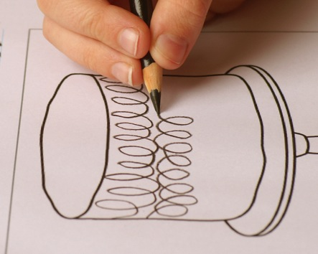

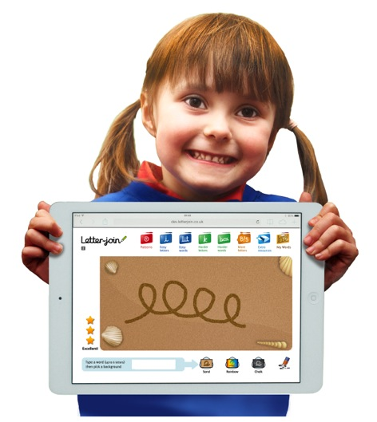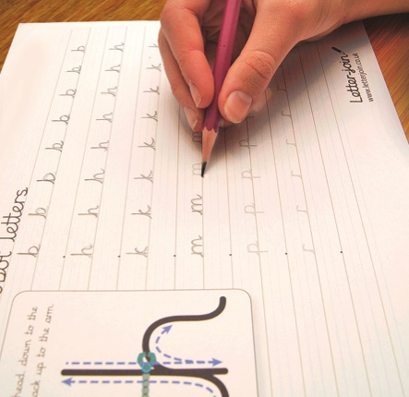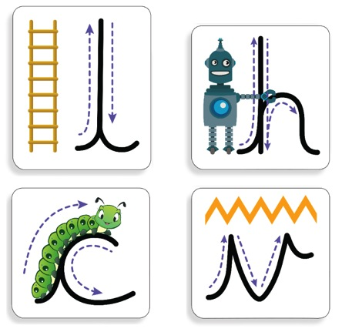

Key Stage Teaching

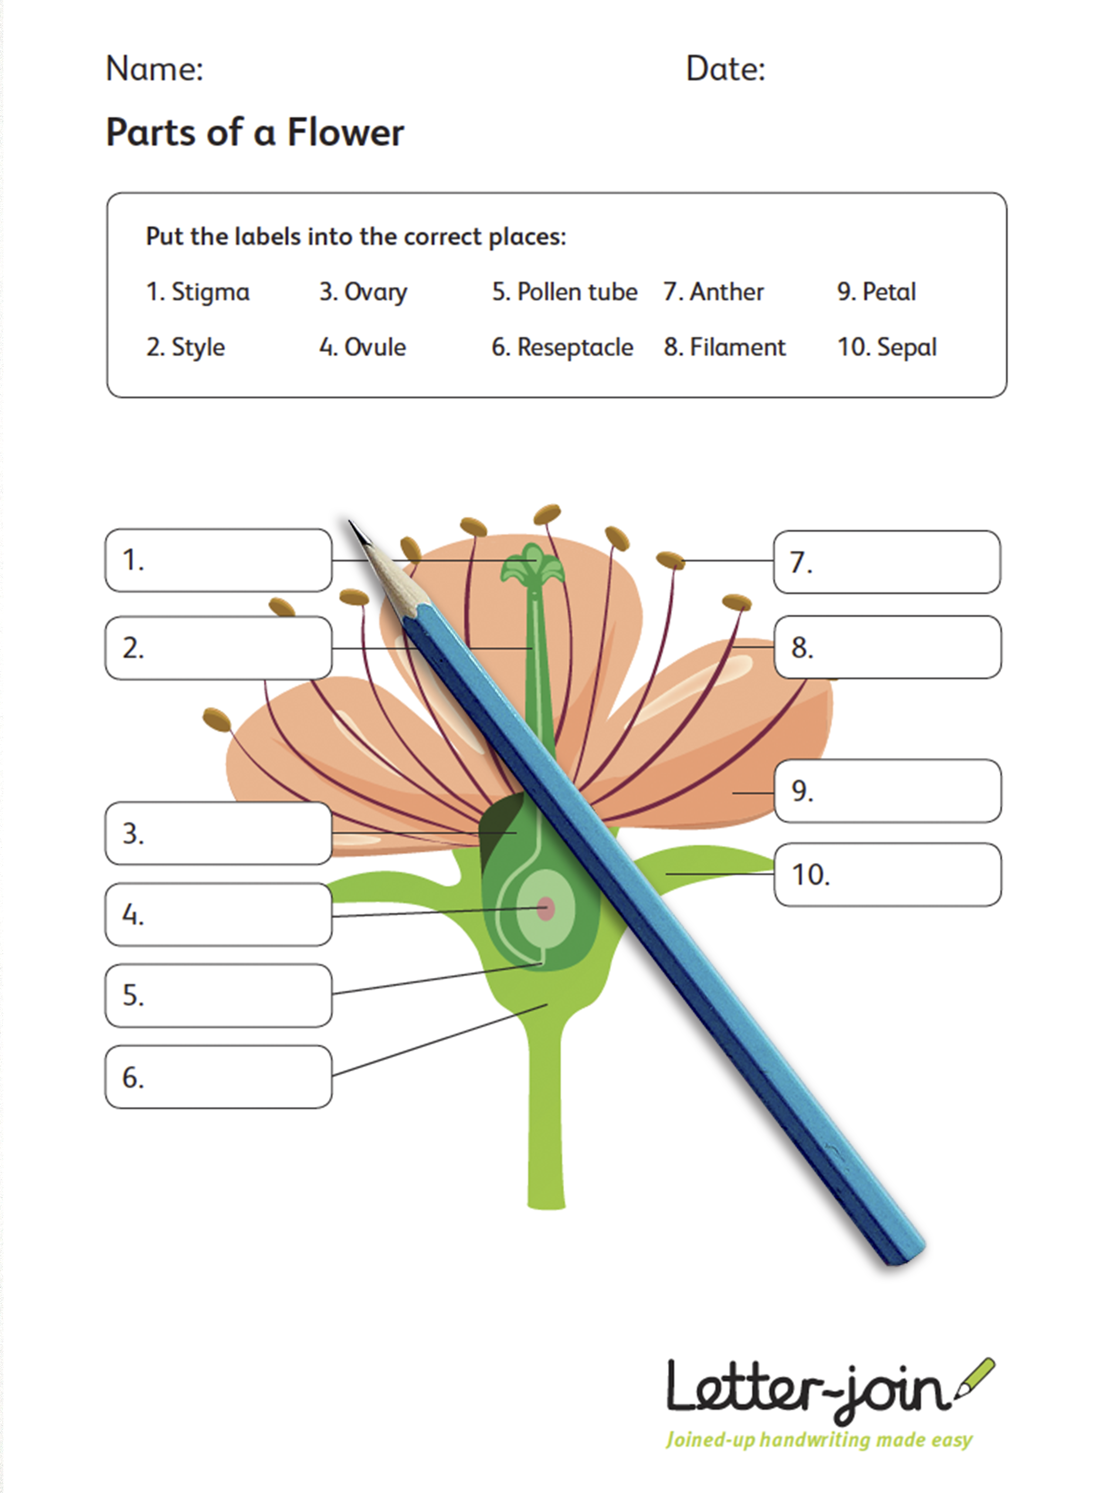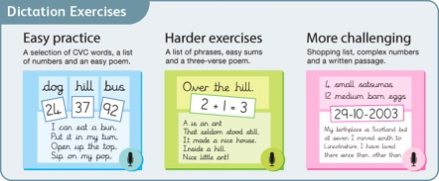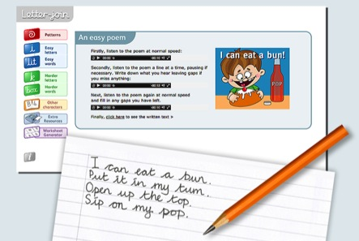

Key Stage 2

Improve quality, speed and stamina of handwriting.

* *Quality*: Ensure letters are consistently sized with equal word spacing and that ascenders and descenders are parallel and do not touch words on the lines above and below.
* *Speed*: Improve speed of handwriting to allow creative writing to take precedence over the task of handwriting and be able to take ‘quick notes’ at a faster pace.
* *Stamina*: Have the strength and mobility to be able to write for longer periods of time without fatigue.

Have full knowledge and ability of the different forms of handwriting for different purposes:

* Neat, joined, cursive letters for writing passages and large amounts of text, lists and letters.
* Printed or capital letters for posters, notices, headings, labelling, and form filling.
* Speedy handwriting for note-taking and dictation where neatness is not as important and shortcuts, such as + instead of ‘and’, can be used.

Key Stage 1

* Write legibly using upper and lower case letters with correct joins.
* Ensure that letters sit on the base line and are consistent in size with ascenders and descenders that are the correct length and formation.
* Leave the correct space between words.
* Form capital letters and use where appropriate.
* Form numerals that are consistent in size and sit on the base line.
* Begin to form printed letters and understand when they are to be used.
* Improve the speed of writing and begin to write automatically so promoting creativity in independent writing.