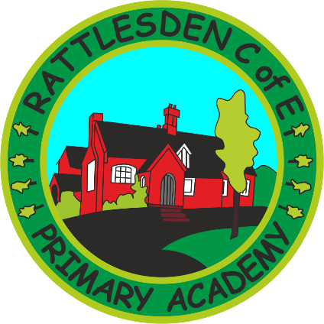
First Aid Policy

 | Name |  | Signature |  | Date
Prepared by: | Mrs Macro |  |  |  | May 2017
Checked and Reviewed by: | Governing Body
Approved by: | Governing Body
Document Title: | Policy – First Aid
Version Number: | 1 | Date of Next Review: |  | May 2019

Rationale
Children and adults in our care need good quality first aid provision. Clear and agreed systems should ensure that all children are given the same care and understanding in our school.
Purpose
This policy;
1. Gives clear structures and guidelines to all staff regarding all areas of first aid;
2. Clearly defines the responsibilities of the staff;
3. Enables staff to see where their responsibilities end;
4. Ensures good first aid cover is available in the school and on visits.
Guidelines
New staff to the school are made aware of this policy when they are appointed. This policy is regularly reviewed and updated. This policy has safety as its priority for the children and adults receiving first aid and safety for the adults who administer first aid.
Conclusion
The administration and organisation of first aid provision is taken very seriously at Rattlesden Primary Academy. There are annual procedures that check on the safety and systems that are in place in this policy. The school takes part in the Health and Safety checks by Thedwastre Academy Trust.
First Aid Policy Guidelines
Training
4 members of our staff have Emergency First aid training and these staff undertake a rolling program of retraining. All staff are aware of the designated members of staff who have this training.
Current First Aiders:
Cheryl Preston expires June 2019
Natasha Leonard expires June 2019
First aid kits
MDSA’s have a first aid box for the playground (for lunchtimes) and this is in the corridor of Lower Beech and can be taken outside when necessary.
First aid kits are stored in individual classes and a larger kit is stored in the disabled/staff toilet. Emergency first aid kits are available for use during out of school visits.

Cuts
All open cuts should be covered after they have been treated with a medi wipe. Children should always be asked if they can wear plasters BEFORE one is applied. Children who are allergic to plasters will be given an alternative dressing. Minor cuts should be recorded in the accident file and parents informed.
ANYONE TREATING AN OPEN CUT WHICH IS BLEEDING SHOULD WEAR GLOVES. All blood waste should be placed in a bag and disposed of in the sanitary bin to be disposed of safely.
Bumped heads
Any bump to the head, no matter how minor should be treated as potentially serious. All bumped heads should be treated with an ice pack and the child should be given an advisory “Bumped Head” letter to take home and return signed. The child’s teacher should be informed and keep a close eye on the progress of the child. ALL bumped head incidents should be recorded in the accident book. Parents will be informed of bumped heads via a phone call and letter home.
Accident file
All classes have their own accident folder and there is one in the MDSAs first aid box. All records are collated in the school office. The accident book should be completed for every incident where first aid is administered.
Adult Accident file
An adult accident file is kept in the office and should be filled in as per HSE guidelines.

Calling the emergency services
Dial 999, ask for ambulance and be ready with the following information:
1. Your telephone number: 01449 736335
2. Give your location as follows: Rattlesden Primary Academy, School Lane Rattlesden.
3. State that the postcode is: IP30 OSE
4. Give exact location in the setting
5. Give your name:
6. Give name of child and a brief description of child’s symptoms:
7. Inform Ambulance Control of the best entrance and state that the crew will be met and taken to the injured party.
It is important to :
Speak clearly and slowly and be ready to repeat information if asked

