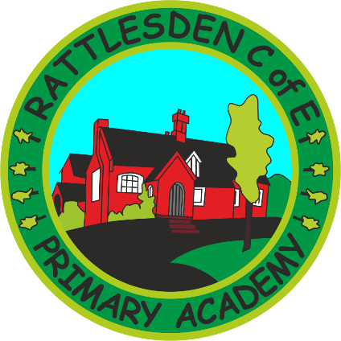
English Policy

 | Name |  | Signature |  | Date
Prepared by: | Mrs McIntosh |  |  |  | February 2019
Checked and Reviewed by: | Governing Body
Approved by: | Governing Body
Document Title: | Policy – English
Version Number: | 1 | Date of Next Review: |  | February 2021

Rattlesden English Policy
Our Essentials
Essential characteristics of writers
- The ability to write fluently with interesting detail on a number of topics throughout the curriculum.
- A vivid imagination which makes readers engage with and enjoy their writing.
- A highly developed vocabulary and an excellent knowledge of writing techniques to extend details or description.
- Well organised and structured writing, which included a variety of sentence structures.
- Excellent transcription skills that ensure their writing is well presented and punctuated, spelled correctly and neat, including reflecting/evaluating/improving writing based on self, peer or teacher feedback.
- A love of writing and an appreciation of its educational, cultural and entertainment values.

All our children will be given the opportunity to write narrative, non-fiction and poetry.

Essential characteristics of readers

- Excellent phonic knowledge and skills
- Fluency and accuracy in reading across a wide range of contexts through the curriculum.
- Knowledge of an extensive and rich vocabulary.
- An excellent comprehension of texts.
- The motivation to read for both study and for pleasure.
- Extensive knowledge through having read a rich and varied range of texts

All our children will be given the opportunity to read and listen to a wide range and style of text, and use school and class libraries

Essential characteristics of excellent communicators

- The ability to listen attentively so as to understand what is being said.
- A rich and varied vocabulary that gives clarity and interest to conversations
- Clear speech that can be easily understood by a range of audiences
- An excellent grasp of the rules used in English conversation, such as tenses and the grammatical structure of sentences.
- A highly developed ability to tell stories that capture the interest and imagination of the audience.
- A delight in initiating and joining in conversations.
- A respect for others when communicating, even when views differ.
All our children will be given the opportunity to engage in meaningful discussions in all areas of the curriculum and speak to small and larger audiences at frequent intervals.
- Content - National Primary Curriculum (2014)

- Organisation:
- Phonics (KS1) – 15/20 minute lessons daily using Letters and Sounds (Support for Spelling/Curriculum 2014 for some Y2 pupils).
- Spelling (KS2) – discrete lessons reinforced in other English lessons. Weekly spellings and spelling tests.
- Guided reading, reading comprehension.
- Quiet reading, individual reading.
- Literacy lessons with a focus on speaking and listening, drama, shared reading and writing.
- Explicit grammar lessons

- Differentiation:
- For ability, not by ability, when appropriate.
- As an element of challenge.
- Teaching across year groups in upper KS2 for some activities

- SEND/Focus groups - Children who are vulnerable or make slower than expected progress (or in Foundation stage and do not have a good level of development) are in focus groups and included in planning.

- ICT – as appropriate, special programs for SEN

- Planning :

- Should be available for supply teachers and Teaching Assistants
- A practical document that is tailored to your class and is more detailed at the beginning of the week
- Foundation stage plans are child led and related to the characteristics of effective learning

- Assessment for learning – see Marking Policy and Teaching and Learning Policy

- Monitoring and Review:
- Peer monitoring
- Medium term planning
- Termly observations by HT

- Handwriting – see policy
- Parental Support:

- Open dialogue through reading logs, homework, face to face contact, reading leaflets
- During the course of the year children will have the opportunity to learn with parents at school
- Assemblies, displays

- Pupil Targets – children know their next steps for learning, updated as appropriate.

February 2019

Related school documents:
Handwriting Policy
End of Year Writing Expectations
Progression of objectives to be covered for S(PAG)

