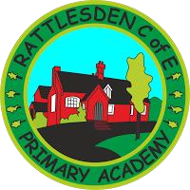

Rattlesden C of E Primary Academy, Rattlesden
KS1 Teacher
MPR
5 mornings a week (0.6 FTE)
Fixed Term Contract for one year.

Required from September 2020.

This is an exciting opportunity for someone who wishes to teach a Year 1 class from September 2020. In the first instance, this will be a fixed term contract for one year.

We would welcome applications from individuals who:
- are an enthusiastic practitioner with knowledge and experience of KS1 Mathematics, English and Foundation subject practice
- set high expectations which inspire, motivate and challenge pupils
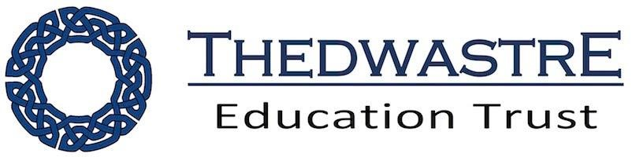
- adapt provision and practice to respond to the strengths and needs of all pupils
- make accurate and productive use of formative and summative assessment
- use positive behaviour management to foster the emotional wellbeing of all pupils and ensure a safe learning environment
- deliver excellent learning and progress outcomes for all children
- liaise with other teachers within school and across the multi academy trust to share and develop good practice.

We are able to offer you:

- A supportive and welcoming team.
- An experienced TA to work alongside.
- Exceptional behaviour with high expectations for pupils and staff alike.
- A nurturing environment where staff are well supported and a clear vision of excellence is shared.

Roll: 124

Visits to our school are encouraged:
Information about our School:
We are a small rural primary school in the beautiful village of Rattlesden near Stowmarket. We are a thoroughly Good school recently inspected by Ofsted in October 2018, rated good in all areas. We have also been judged Good as a church school (Diocesan Inspection). We have a strong Christian ethos throughout the school, a supportive and active PTA, and a strong team of hard working and dedicated teachers, support staff and governors. We have delightful, enthusiastic children who are eager to learn. You are invited to become part of our team.

Rattlesden is part of the Thedwastre Education Trust.
For more information or to arrange a visit please call: 01449 736335 or visit our website.

Closing Date: Midday 15th June 2020
Interview Date: W/C 29th June 2020

Please return a completed application form to the school.
Our School and all its personnel are committed to safeguarding and promoting the welfare of the children. This post is subject to an Enhanced Disclosure Application to the Disclosure and Barring Service.

