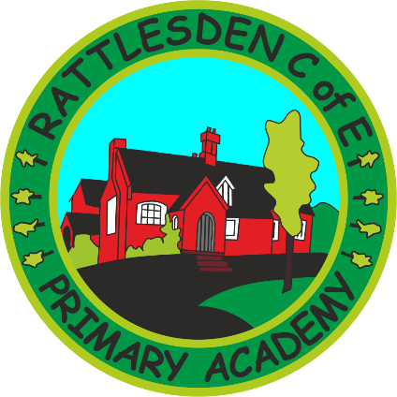
British Values Policy

 | Name |  | Signature |  | Date
Prepared by: | H Ballam |  |  |  | October 2017
Checked and Reviewed by: | Governing Body
Approved by: | Governing Body
Document Title: | Policy – British Values
Version Number: | 1 | Date of Next Review: |  | October 2020

SMSC and Promoting Fundamental British Values
The pupils of Rattlesden School show mutual respect for and celebrate the similarities and differences of all ages, abilities and cultures. We actively promote the pupils’ SMSC development through our curriculum and enrichment opportunities and the fundamental British Values are an integral part of this.
At Rattlesden School ‘British Values’ are considered in the following ways:
DEMOCRACY
“Develop an understanding of how citizens can influence decision-making through the democratic process”
Democracy is embedded within the ethos of Rattlesden School.
Staff encourage children to know that their views count, to value each other’s views and to talk about their feelings. This voice can be through the school council, suggestions box and nurture groups.
School Council - The election of School Council members reflects the British electoral system. Pupils consider the necessary characteristics for an effective pupil council member and vote using a secret ballot. The School Council meet regularly to bring suggestions to the table from their peers and make decisions about ways to improve the school for the benefit of all. Examples of positive changes made are – designing and choosing equipment for our outdoor play areas, being involved in the implementation of healthier choices at the tuck shop, planning reward activities and charity events.
RULE OF LAW
“Develop an appreciation that living under the rule of law protects individuals and is essential for their wellbeing and safety”
Staff ensure that children understand their own and others’ behaviour and its consequences. Students learn to distinguish right from wrong through discussions and the modelling of positive behaviour and by the implementation of the House system. These encourage pupils to be kind and helpful, listen carefully, work hard, look after things, be honest and be gentle. Pupils who are observed putting these rules into practise are rewarded with house points. House points and Assembly Awards are important motivators for pupils. Individual classes may decide upon their own reward system in addition to the whole school approach.
Pupils are taught the value and reasons behind laws, that they govern and protect us, the responsibilities that this involves, and the consequences when laws are broken. These values are reinforced in different ways:
- Visits from authorities such as the police and ambulance service
- Religious Education, during which rules from different faiths are considered.
- Other curriculum subjects, where there is a need for respect and appreciation of different rules – e.g. P.E.
INDIVIDUAL LIBERTY
“Develop an understanding that the freedom to choose and hold other faiths and beliefs is protected by law”
Staff support all pupils to develop positive self esteem, self awareness and self confidence. We recognise that pupils have various learning styles and provide opportunities for pupil led learning.
Through Learning Targets and challenges built into the lessons pupils are encouraged to take ownership of ways they can improve their learning and progress, giving them a sense of personal and social responsibility.
The school partakes in Anti-Bullying week. They are encouraged to speak out should they feel intimidated, frightened etc in any way or for any reason. Our Learning mentor works with children that have low self-esteem using Sand Therapy sessions.
The Buddy Bench in the playground provide pupils with a safe place to go at playtimes. Peer mentors are known to the children and are encouraged to approach anyone sitting at the Buddy Bench and ask if they would like to play with or talk to them, ensuring no child is alone if they don’t want to be. There is also a ‘quiet’ area for children who want to escape the business of the playground, and a ‘Quiet Club’ for children who find lunchtimes daunting, or who can display poor behaviour and need support in this aspect.
Pupils also make choices around House reward activities, Golden Time and extra-curricular enrichment clubs.
MUTUAL TOLERANCE AND RESPECT
“Develop an acceptance that other people having different faiths or beliefs (or none) should be accepted and tolerated and should not be subject to prejudice or discrimination.”
Inclusion, mutual tolerance and respect are at the heart of Rattlesden C of E Academy’s aims and ethos We believe that each person is respected and valued equally without regard to faith, heritage, race, ability or gender.
Staff aim to enhance pupils understanding and respect for different cultures, faiths and beliefs through our curriculum, examples are;
- Creative Arts - by considering cultures from around the world through music, art and dance.
- Knowledge & Understanding of the World - through organising Themed Weeks where we celebrate and enjoy the differences between other countries and cultures.
- Literacy and ICT – where there are opportunities to explore cultures and traditions using a wide range of fiction, non-fiction texts and the internet.
- PSHE and Philosophy – where discussion and debate are important tools for promoting mutual tolerance and respect.
- Scientific Learning- in which practical activities require students to engage in teamwork and show mutual respect for each other.
We also encourage involvement in;
- Charity Events where pupils are made aware of the needs of people both in our own and other countries, supporting them through national fund raising events such as the Kagera appeal, Children in Need, Shoe Box Appeal, Comic Relief and Sports Relief.
- The Kagera appeal links us directly with a community that is diverse from our own. Visitors form the diocese bring to life first hand their experiences working with this community.
- Fair Trade is a topic that is explored in Key Stage 2 with visitors from the scheme coming to the school to explore in detail the rationale behind it.
At Rattlesden C of E Academy we are dedicated to ensuring our pupils develop a strong sense of social and moral responsibility, preparing them for life in Modern Britain where, in an ever changing society they understand the importance of and are able to uphold the fundamental British Values of democracy, rule of law, individual liberty and mutual tolerance and respect for others.

